BirdLife/Wirambi Landcare Tree Martin (Petrochelidon nigricans) Survey – Summary of Results January 2025
Sophie McHutchison (Wirambi Landcare Group) and
Dr Geoff Barrett (DBCA Regional Ecologist)
February 2025

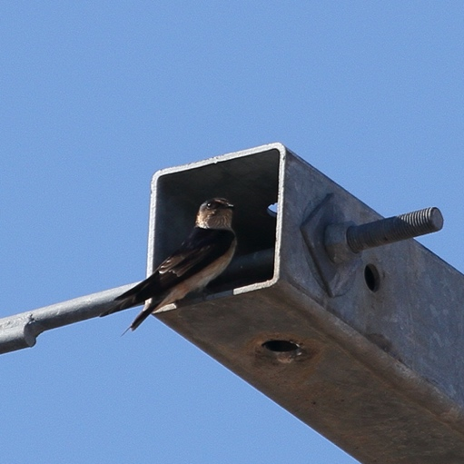

Tree Martin at nest location in street power pole (Image by Ian Wallace, 2017).

Summary
Over a five-month period, from September 2024 to January 2025, vehicle-based surveys of street power poles identified 33 Tree Martin nests, 30 of which were in the cross bars of street power poles. Most of the nests were close to remnant, native vegetation (52%) or urban parkland (21%), and almost half of all nests were within 500m of a wetland (48%).
A total of 852 street power poles were surveyed, a quarter of which (24%) had open cross bars, available to martins as nesting sites, and 18 of these poles had martin nests (0.2% of all 852 poles surveyed). If martins were observed as being present in an area, at the time of survey, over a quarter (27%) of the poles with nest sites available (116 poles), were occupied by martin nests.
Along streets that are close to wetlands and remnant native vegetation, where Tree Martins are present, almost a third of the street power poles had martins breeding in them, suggesting that street power poles are a valuable breeding resource for this small, woodland bird.
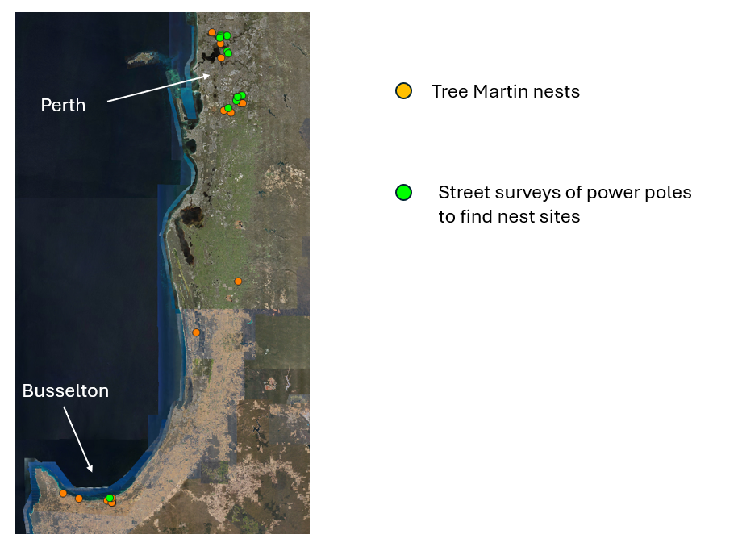
Figure 1: Location of 33 Tree Martin Nests across Perth and Busselton (orange dots) and location of 18 street surveys of power poles to estimate the proportion of power poles with nest sites available, and occupied by martin nests (green dots).

Martin Nest Location
Survey Period: 17 September 2024 to 3rd January 2025

Method: Nest were identified opportunistically, usually while driving on the quieter streets, looking out for martins flying into or out from nests in power poles. The date and location of the nest was recorded, as well as the surrounding land use. See Appendix 1 for a description of survey methods.

Results: A total of 33 Tree Martin nests were located (see map Figure 1), 30 nests (94%) occurred in street power poles (mostly in the metal cross bars), two nests occurred in streetlights, and one nest was recorded in a roof structure (Figures 2 and 3).

Table 1: Surrounding land use of Tree Martin nests
Surrounding Land Use | Number of nests | %
Remnant vegetation and Urban Housing | 17 | 52
Within 500m of wetland | 16 | 48
Urban Parkland and Housing | 7 | 21
Semi-Rural Farmland | 6 | 18
All Urban Housing | 3 | 9

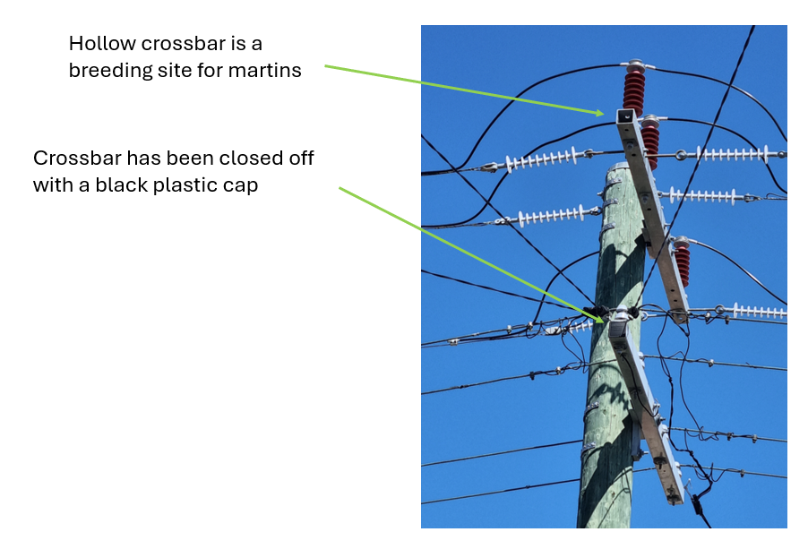

Figure 2: Street power pole with hollow, metal cross bars, which serve as nest sites for Tree Martins. Note the lower cross bar has been capped with a black plastic cap, preventing its use as a nesting site.

Proportion of street power poles occupied by Tree Martins

Survey Period: 17 September 2024 to 3rd January 2025

Method: Quiet roads with street power poles, were treated as linear transects. The observer would drive slowly along the road, recording the number of power poles with martin nest sites available (open cross bars, Figure 2) and the number of poles without nest sites available (closed cross bars). The presence of martins flying within 100m of the street was recorded, as well as any observations of martins using power poles as nesting sites. If martins were seen flying close to a pole, the vehicle was stopped and the pole observed for five minutes, to see if a martin was breeding there. See also, Appendix 1 for a description of survey methods.

Results:
Total number of street power polls surveyed = 852
Total number of polls with martin nest sites available = 204 (24%)
Total number of polls being used by martins = 18 (0.2%)

Table 2: Proportion of street power polls with Tree Martin nests
Street Power Poll | Martins Present | Martins Absent
Polls with no martin nest sites available | 362 | 286
Polls with martin nest sites available but not being used | 116 | 70
Polls with martins nesting | 18 | 0
% Polls with nest sites available | 27% | 20%
% Available Polls with martins nesting | 13% | N/A
Total # Poles surveyed | 496 | 356

Appendix 1: Data Sheets and description of survey methods
