

Swan Canning Estuary seagrass health status assessment 2024-25
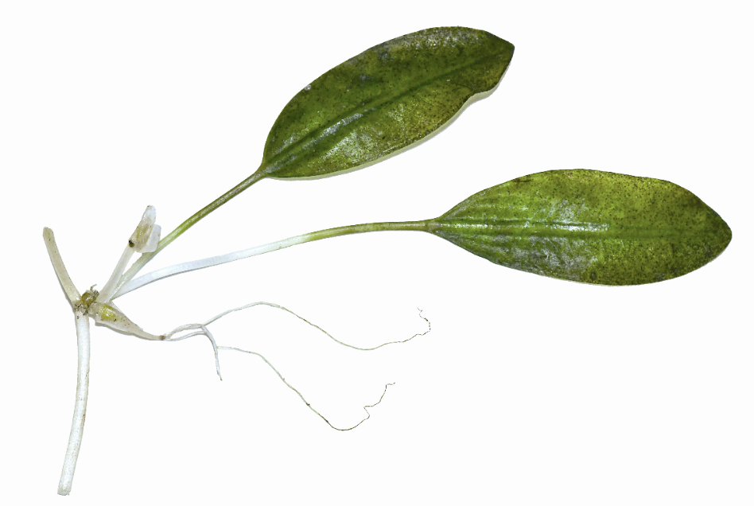


Department of Biodiversity, Conservation and Attractions
Locked Bag 104
Bentley Delivery Centre WA 6983
Phone: (08) 9219 9000
Fax: (08) 9334 0498

www.dbca.wa.gov.au

© Department of Biodiversity, Conservation and Attractions on behalf of the State of Western Australia 2026

This work is copyright. You may download, display, print and reproduce this material in unaltered form (retaining this notice) for your personal, non-commercial use or use within your organisation. Apart from any use as permitted under the Copyright Act 1968, all other rights are reserved. Requests and enquiries concerning reproduction and rights should be addressed to the Department of Biodiversity, Conservation and Attractions.

This report was authored by Charlie Phelps, Peter Howie and Jarra Chapman.

Questions regarding the use of this material should be directed to:
Principal Scientist
Rivers and Estuaries Science
Biodiversity and Conservation Sciences Division
Department of Biodiversity, Conservation and Attractions
Locked Bag 104
Bentley Delivery Centre WA 6983
Phone: (08) 9278 0900
Email: riversandestuariesscience@dbca.wa.gov.au

The recommended reference for this publication is: Phelps, C. M., Howie, P. A., & Chapman, J. (2026). Swan-Canning Estuary seagrass health status assessment 2024-25. Annual data report, Department of Biodiversity, Conservation and Attractions, Perth.

This document is available in alternative formats on request.

Cover photograph: Halophila ovalis leaf pair showing reproductive modes - sexual female reproductive structure and - asexual vegetative growth branch with apices (photo credit: Miles Brotherson).

The Department of Biodiversity, Conservation and Attractions would like to thank the following for their contribution to this publication:
Dr Charlie Phelps (author), Peter Howie (author), Jarra Chapman (author), Dr Kerry Trayler (strategic and funding support; review).
Field assistants: Jake Watsham, Lucy Arrowsmith, Riley Karker, Bella Kaden.
Volunteers: Natalie Wolfe, Elaine Christy, Michael Paterson, Isaac Ledger, Lilly Kunum, Billie McDonald, Lachlan Trainer, Lana Weir, Thomas Law, Weng Mun Ong, Maggie Reitsma, Raelene Smith, Maddie Harvey, Lingtoa Wang, Sheona Meisinger, Pauline Arnold, Moluk Alesa, Jordan White, Bernice (Chujing) Qin, Marta Mrasic, Joy Chew, Nadia Canon Delgardo, Kai (Wei Kai) Phang, Taylor Whyatt, Max Judson, Angelica Hang, Erin Greenwood, Remi Charin, Riddhi Makwana, Michael Hand, Francesca Foschi, Megan Reagon, Ann Bird, Sofia Min, Vicki Bailey, and Angus Young.
Contents
Executive Summary 1
Introduction 1
Significant findings 1
Recommendations 2
Sampling methodology 3
Site locations 3
Sampling dates 5
Measured parameters 5
Indicators for measuring seagrass health 6
Indicators for measuring seagrass pressures 7
Environmental variables 7
Seagrass performance 10
Overall seagrass performance metric 10
Seagrass performance indices 11
Seagrass presence/absence 11
Seagrass cover 13
Halophila ovalis reproduction 15
Seagrass biomass 17
Ancillary performance measurements 19
Leaf density 19
Seed density 20
Environmental conditions 21
Noteworthy environmental conditions 21
Rainfall 22
Tidal variations 23
Salinity 24
In-situ water temperature 26
Air temperatures 27
Global solar exposure 27
Benthic light 28
Wind speed and direction 30
Seagrass pressures 32
Macroalgal cover 32
Ancillary pressure measurements 35
Batillaria australis density 35
Appendices 37
Overall seagrass performance score 37
Proportion of depths at each site 37
Seagrass species composition 38
Nutrient levels and macroalgae cover in the Canning River 39
January storm surge 41
Statistical data 41
Statistical results - seagrass presence/absence 41
Statistical results - seagrass cover 42
Statistical results - reproduction 44
Statistical results – biomass 45
Glossary 48

Executive Summary

Introduction
This seagrass monitoring program assesses the health and productivity of seagrass communities within the Swan Canning Estuary (hereafter ‘the Estuary’). The program was established to implement a robust, repeatable method for surveying seagrass meadows and evaluating estuary-wide ecosystem condition. The results of this monitoring contribute directly to reporting on overall Estuary health, supporting the objectives of the Swan Canning River Protection Strategy.
Six sites within the Swan–Canning Estuary were surveyed throughout the austral spring and summer periods of 2024 and 2025 as part of ongoing ecological monitoring of the system. At each site, a suite of seagrass indices, including presence, percentage cover, reproductive effort, and above/below ground biomass were measured. These indices are integrated into an overall seagrass performance score, which provides a quantitative indication of seagrass health and allows comparisons across sites and years.
To strengthen interpretation of the 2024–2025 results, data from the preceding year/s are also included in this report. Presenting multiple years of observations allows for clearer identification of temporal patterns, interannual variability, and emerging trends in seagrass condition within the estuary. This contextual information is essential for understanding ecosystem responses to environmental pressures and for informing adaptive management of the Swan–Canning Estuary system.

Significant findings
Anomalous weather conditions were present within this reporting period. A severe marine heatwave in northwest Western Australia coupled with a strong Leeuwin Current influenced water temperature in the West Coast Bioregion with elevated sea surface temperatures from October and rapid warming in January. Moderate heatwave conditions continued in this bioregion into February, but strong southerly winds abated extreme conditions. Sea surface temperatures were elevated through to June. High tides were experienced over spring and summer in association with an 18.61 year lunar cycle. Tidal residual peaked in January as a low-pressure system associated with ex- tropical cyclone Sean, caused additional storm surge.

These weather events influenced seagrass communities as noted below.
Notable observations include:
- Despite the marine heatwave, seagrass sites within the Estuary experienced lower water temperatures in 2024-25 than previous years, attributable to the higher tide conditions;
- All sites produced a ‘good’ overall seagrass performance score for the 2024-25 reporting period;
- Macroalgae was persistently high throughout the season (despite low rainfall all year) and dominated by colonising species Hypnea;
- Heathcote was the only site that scored consistently ‘good’ across all seagrass performance indices.

Recommendations
- Future focus on the Milyu site, three of the four indices were rated as ‘fair’, with only the index presence achieving a ‘good’ score. This pattern reflects extensive areas of sparse seagrass cover at Milyu potentially due to high levels of macroalgal cover and high frequency and intensity of south-westerly winds increasing turbidity. Milyu has a higher proportion of deeper zones comparative to other sites and increase turbidity may impact light attenuation in these zones and reduce seagrass growth. Notably, the site also received an overall ‘fair’ performance rating for the 2023–24 season (Supplementary table 1).
- Continue utilising the current performance and pressure indices while validating and refining these indicators to ensure the delivery of optimal monitoring outcomes.

Sampling methodology

Site locations
Seagrass occurs across an estimated 590ha in the Swan Canning estuary, with approximately 40% occurring within the Swan Estuary Marine Park. For purposes of assessing seagrass health, monitoring occurs at six sites in the Estuary (Figure 1). These sites were selected as known areas with persistent Halophila ovalis habitats and differing environmental and physical features (depth and bathymetry) as representative of the conditions across the Estuary. Of these sites, Milyu (MIL), Pelican Point (PPT) and Lucky Bay (LUB) are within the Swan- Estuary Marine Park. As such, these sites are expected to be less impacted by anthropogenic disturbances, additionally, the foreshore nearby is often the focus of additional conservation efforts by community groups. Conditions can vary at these sites, for example, MIL and PPT can be impacted by south-westerly winds, which can reduce water clarity, particularly at MIL, winds can increase turbidity by resuspending fine sediments. Conversely, the Heathcote (HEA) and LUB sites are somewhat protected from south-westerly winds. HEA having the highest area of all sites at moderate depths often produces the healthiest seagrass metrics and LUB being the shallowest site, can be the site most impacted by seagrass exposure on low tides. Canning (CAN) is the most upstream site and is representative of the upstream limit of seagrass habitat in the Estuary. It is the site most influenced by tannin-stained water, high turbidity, high macroalgae cover, and silty sediment from freshwater input from the upstream catchment. Conversely, Rocky Bay (RCK) is the most downstream site and is the most marine influenced monitoring site. Two marine seagrass species Posidonia australis and Zostera muelleri subsp. mucronate persist at RCK there the salinity is comparable to marine conditions, and the sediment is coarser and contains a high amount of calcareous shell grit. (HEA), Milyu (MIL) and Canning (CAN).
Sites vary in depth, with different proportions of the total site area falling into depth categories (Supplementary figure 1). These depth differences can have unique influences on environmental conditions and light attenuation at each site. For example, Lucky Bay is a relatively shallow site, which may influence seagrass cover, particularly in relation to tidal exposure, elevated water temperatures in shallow zones, and decrease light attenuation. Shallow areas can also experience greater fluctuations in salinity and water movement, which may further affect seagrass growth.

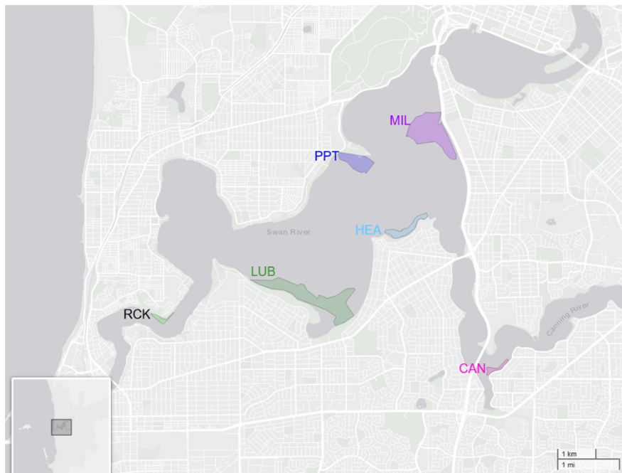
Figure 1: Seagrass sites within the Swan-Canning Estuary. Rocky Bay (RCK), Lucky Bay (LUB), Pelican Point (PPT), Heathcote

Sampling dates
Seagrass and environmental data sampling are conducted between October and March, to capture H. ovalis (the dominant seagrass in the system) in its reproductive cycle and a state of high productivity. In the 2024-25 seagrass period, metrics were collected as follows:
- Focal area quadrat sampling was conducted from November to March;
- Core samples were analysed between December and March;
- In-situ light and temperature loggers were deployed in mid-October, with comprehensive data recorded from mid-October to mid-March; and
- Data from external government departments and organisations (e.g., Department of Transport and Bureau of Meteorology) is collected on an annual basis.

Measured parameters
The seagrass monitoring program undergoes continuous evaluation and validation to ensure that reporting accurately reflects seagrass condition and to allow for uptake of emerging technologies. Upon reflection of the substantial time required to complete the seagrass/sediment/water chemistry and the extensive survey concurrently in February 2024, a decision was made to shift the extensive survey to ‘Year 2’ in the 5-year reporting cycle (Table 1). The second year was selected for not coinciding with the other high demand metrics that occur in addition to the regular monitoring program. Therefore, the next extensive survey will be repeated two years in advance (February 2027) within the upcoming 5-year reporting cycle only. The Dalkeith (DLK) site was regularly monitored as part of the seagrass monitoring program by the Department of Water between 2011 and 2019, the site was removed from the program due to high anthropological activity at this site and recurrent loss of equipment and was replaced by the MIL site within the marine park. To understand changes over time at DLK, commencing 2026-27, this site will be monitored as part of the intensive quadrat survey. Additionally, the DLK and Karrakatta Bank (KAR) will be included in the 5-yearly deep edge survey commencing 2025-26, as KAR is a known habitat for the deeper benthic species, Halophila decipiens. This reporting season will be undertaken in ‘Year 5’ in the 5-year reporting cycle (Table 1).

Table 1: The full indicator suite and timing across the 5-year reporting cycle. Additional metrics highlighted in bold; 2024-25 is year 5 in the reporting cycle highlighted in bold.
Metrics | Year 1 | Year 2 | Year 3 | Year 4 | Year 5
Seagrass performance metric (see table 2)
Distribution survey (extensive quadrats including Dalkeith (DLK) site)
System-wide distribution map
Seagrass ‘deep edge’ survey including Dalkeith (DLK and KAR) sites
Seagrass pressure metric (Macroalgae cover and B. australis densities)
Seagrass chemistry
Environmental metrics
Sediment and water chemistry

Indicators for measuring seagrass health
The performance indices (presence/absence, percent cover, reproduction, and total biomass) contribute to the overall seagrass performance metric and are used to assess seagrass health in the Estuary (Table 2). Above/below ground biomass ratio, leaf, fruit and seed densities have been included as ancillary indices in the ‘Ancillary performance measurements’ section of this report to assist in identifying any observed changes in seagrass health.
Table 2: Indices calculated to inform on seagrass PERFORMANCE in the Swan-Canning Estuary. Indices with a grey background are used in the calculation of the final performance metric.
Indicator | Timing / Freq. | Detail | Performance classification or interpretation (where applicable)
Presence/ absence | - Dec – Feb  - Yearly  - Focus area quadrat survey | % of quadrats with seagrass present | Poor < 0.2  Low 0.2 to < 0.5  Fair 0.5 to < 0.8  Good > 0.8
% Cover | - Dec – Feb  - Yearly  - Focus area quadrat survey | Average % cover of seagrass | Poor < 5%  Low 5% to < 25%  Fair 25% to < 50%  Good > 50%
H. ovalis reproduction | - Dec – Mar  - Yearly  - core analysis | Average density of flowers and fruit (per sqm) | Poor < 50 flowers m⁻² and 0 fruit m⁻²  Low > 50 flowers m⁻² and 0 fruit m⁻²  Fair 1-20 fruit m⁻²  Good >300 flowers m⁻² or >20 fruit m⁻²
Total biomass | - Dec – Feb  - Yearly  - core analysis | Average dry-weight biomass of seagrass (grams per dry weight per m²) | Poor < 60 g/m^2 dry weight  Low 60 to < 90 g/m^2 dry weight  Fair 90 to < 120 g/m^2 dry weight  Good ≥ 120 g/m2 dry weight
Above/below ground biomass ratio | - Dec – Feb  - Yearly  - core analysis | Average ratio of the above ground to below ground biomass | Higher ratio indicates greater above ground growth which indicates high investment in photosynthetic tissue. Lower ratio indicates greater below ground growth, where the seagrass has invested in below ground carbohydrate storage.
Leaf density | - Dec – Feb  - Yearly  - core analysis | Average density of leaves (per sqm) | Higher leaf densities suggest higher productivity, and are considered indicative of better seagrass health
Fruit and seed density | - Dec – Feb  - Yearly  - core analysis | Average density of fruit and seed (per sqm) | Higher fruit densities would produce a higher seed count and are indicative of a greater reproductive capacity.

Indicators for measuring seagrass pressures
The full pressure metric, which requires the chemical analysis (δ15N in leaves, F-sulphide, C:N) will only be assessed once in the 5-year reporting cycle (4th year; next occurrence 2028-29; Table 1). Therefore, an overall pressure metric is not included in this report. The pressure indicator ‘macroalgal cover’ is obtained as part of the yearly quadrat data and is presented in this report (see Macroalgal cover). Batillaria australis densities have been included as an ancillary indicator in the ‘Ancillary pressure measurements’ section of this report (Table 3).
Table 3: Indices applied in calculation of a PRESSURE metric for seagrass in the Swan-Canning Estuary. Indices with a grey background are used in the calculation of the final pressure metric.
Indicator | Timing / Freq. | Detail | Performance classification or interpretation (where applicable)
% Macroalgae cover | - Nov – Mar  - Yearly  - Quadrat survey | Average % cover of macroalgae | High stress > 80%  Moderate-high stress 50 to < 80%  Moderate-low stress 20 to < 50%  Minimal stress < 20%
δ15N in leaves | - Feb  - Quinquennial  - Core analysis | Ratio of 15N radio-isotope in leaves compared to local inorganic standard | High stress >9  Moderate-high stress >7 to 9  Moderate-low stress 5 to 7  Minimal stress <5
F-sulphide | - Feb  - Quinquennial  - Core analysis | Sulphide stress in seagrass tissue by estimating sulphide intrusion | High stress >40%  Moderate-high stress >30-40%  Moderate-low stress 20-<30%  Minimal stress <20%
C:N | - Feb  - Quinquennial  - Core analysis | Average ratio of carbon to nitrogen in leaves | High stress <17  Moderate-high stress 17 to <19  Moderate-low stress 19 to 21  Minimal stress >21
Batillaria australis density | - Dec – Feb  - Yearly  - Core analysis | Average density of B. australis (per sqm) | B. australis shells provide a hard substrate for algae holdfast growth, potentially promoting higher macroalgal cover, restricting light penetration to the seagrass below. Additionally, snail bioturbation can displace seagrass rhizomes, roots and sediment, influence light, sediment oxygen and nutrients.

Environmental variables
In addition to the above biotic metrics, several environmental measures that have the potential to impact seagrass performance and health are also monitored (Table 4).
Table 4: Measured environmental variables with brief potential impact on seagrass.
Variable | Timing / Freq. | Detail | Interpretation
Spring rainfall | - Sept – Nov  - Yearly  - data from Perth Metropolitan meter | Average monthly rainfall (mm) | Rainfall in spring brings nutrients into the system at a time when water clarity and temperatures are favourable for macroalgal growth. Macroalgae compete with seagrass for light and nutrients and may cause ‘death zones’ where large accumulations of wrack decompose and cause sediment anoxia underneath them.
Summer rainfall | - Dec – Feb  - Yearly  - data from Perth Metropolitan meter | Average monthly rainfall (mm) | Significant summer rainfall events are considered a substantial stressor for seagrass. Sudden decreases in salinity can result in significant die-off. Tannin rich riverine flows, or sediment displacement may severely impact water clarity.
Tide | - Nov – Feb  - Yearly  - Barrack Street Jetty and Fremantle Jetty,  - data collated from Department of Transport | Average tide height (cm) at each location | Tide influences the depth of water above the seagrass meadow. Higher tidal heights suggest that less light reaches the seagrass meadow, while lower tidal heights mean potential temperature increases for seagrass growing in the shallows. Also, increased risk of seagrass exposure if intertidal zones occur.
Salinity | - Oct – Mar  - Data collected within the Swan-Canning DBCA water quality monitoring project at sites within the Estuary in close proximity to the seagrass monitoring sites | Average salinity in ppt | Variability in salinity levels  can impact seagrass health, particularly for the sites downstream which often experience stable salinity levels.
Water temperature | - Nov – Feb  - Yearly  - in-situ logger measurements | Average water temperature measured at the seagrass canopy (°C) | Moderate temperatures are most favourable. Low temperatures reduce metabolic rates and growth, while high temperatures can result in physiological damage. Water temperatures can be influenced by tides, depth, particulates in water and turbidity.
Air temperature | - Sept – Feb  - Yearly  data from Bureau of Meteorology’s daily global solar exposure model | Average daily air temperatures in Perth (°C) | Recorded air temperature at Perth Metro Station 009225. Prolonged hot air temperatures have a direct relationship with water temperatures, as does low air temperatures with colder water temperatures.
Global solar exposure | - Oct – Feb  - Yearly  data from Bureau of Meteorology’s daily global solar exposure model | Average daily global solar exposure (MJ m⁻²) | Higher daily solar exposure means more light is available for photosynthesis and growth.  *This is an atmospheric measurement and does not take water conditions into account.
Benthic light | - Oct – Feb  - Yearly  - in-situ logger measurements | Average daily irradiance (mol quanta m⁻² day⁻¹) | Two sensors at each site measure Photosynthetically Active Radiation (PAR) within proximity to the seagrass canopy. Increased benthic light yields suggests increased seagrass growth and carbohydrate storage potential.
Wind speed and direction | - Nov-Mar  - Yearly  - Data recorded at Melville Water (Station number 9091) | Average wind speed as metres per second, direction of wind and frequency of occurrence. | Wind speed may impact sedimentation, and direction will determine which sites are impacted.

Seagrass performance

Overall seagrass performance metric
The overall seagrass performance metric is assessed based on the seasonal outcomes of the presence/absence, cover, reproduction, and biomass indices (Table 2). Independently each indicator is scored from 1 to 4 for each site and season, and the score is based on the individual performance classifications for each of the indices. For example, these scores are categorised from ‘poor’ (red; score of 1) to ‘good’ (green; score of 4). Then for each season and site, the scores across all indicators is averaged to determine the overall seagrass performance for that season (Supplementary table 1).

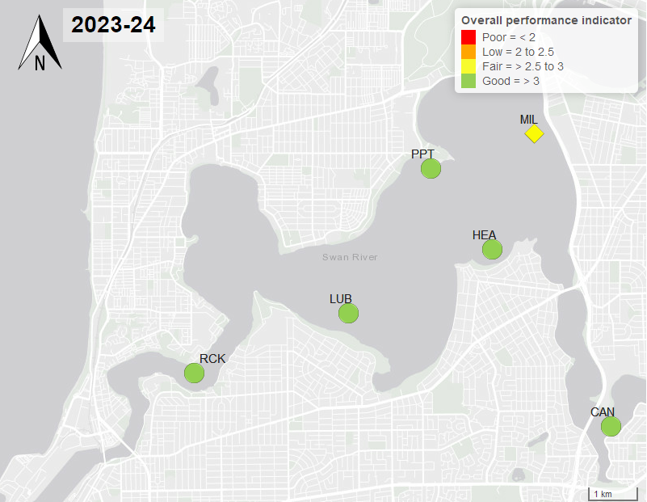
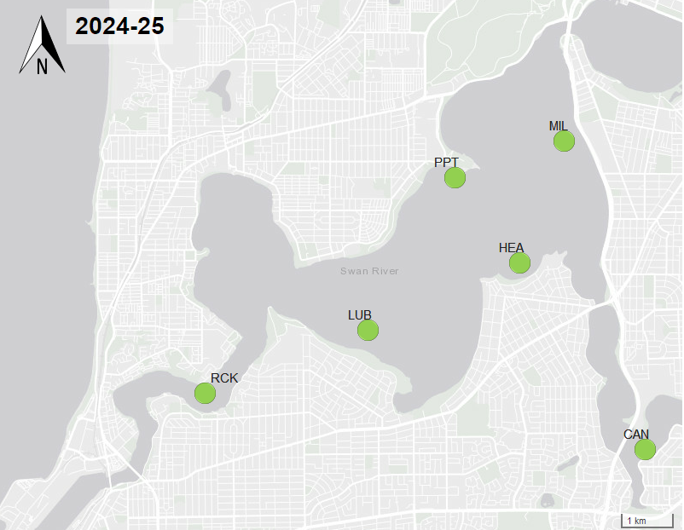
Figure 2: Map of overall performance metric for the survey in the 2023-24 (top) and 2024-25 (bottom) seagrass seasons.
Seagrass performance was ‘good’ at all six sites in 2024-25 (Figure 2; Supplementary Table 1). The MIL site improved from the previous year (3.0 in 2023-24 to 3.5 in 2024-25), due to an increase in seagrass presence at this site (discussed below; Seagrass presence/absence).

Seagrass performance indices

Seagrass presence/absence
Seagrass presence is an evaluation of the area within a site that contains seagrass and is measured as proportion of quadrats with seagrass present. A presence/absence score of 0 indicates that no quadrats sampled contained seagrass and is indicative of very low to no seagrass presence at the site. A score of 1 would indicate that every assessed quadrat contained seagrass, suggesting the site has high seagrass presence to complete coverage at the meadow scale.
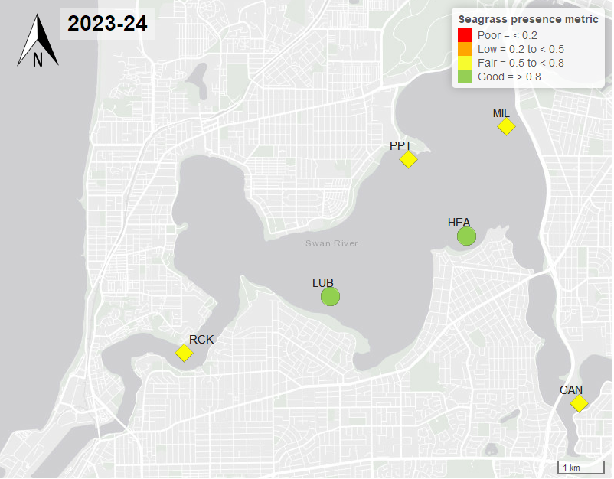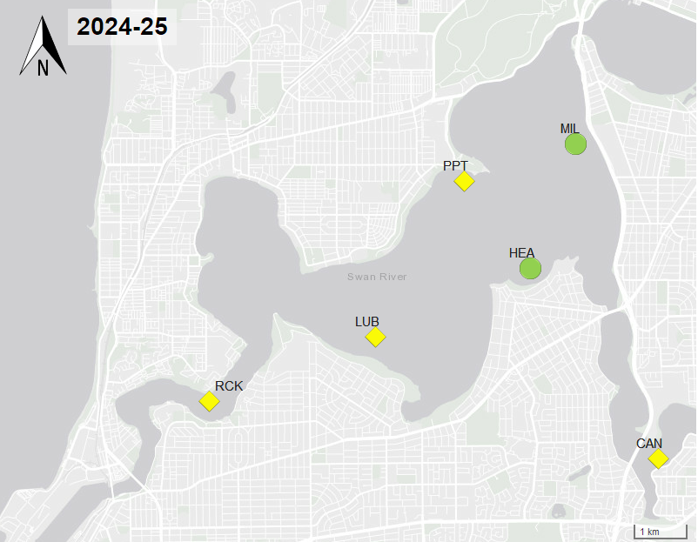
Figure 3: Map of seagrass presence classification for the survey in the 2023-24 (top) and 2024-25 (bottom) seagrass seasons.
In 2024-25, the seagrass presence at RCK, LUB, PPT, and CAN was ‘fair’ (Figure 3). The overall seagrass presence in 2024-25 (0.73 ± 0.02 SE) reduced from the previous year (0.76 ± 0.02 SE) and again from the recorded 4-year historical average (0.82 ± 0.01 SE; Figure 4). The three sites, RCK, PPT and CAN, maintained a ‘fair’ performance score between 2024-25 and the previous year. A decline in presence at the LUB site in 2023-24 (0.82 ± 0.05 SE) to 2024-25 (0.7 ± 0.06 SE), placing this site into the ‘fair’ category. However, MIL improved from 0.77 (± 0.06 SE) presence to 0.83 (± 0.05 SE), placing this site in the ‘good’ category while having the highest average seagrass presence compared to all other sites. Notable was seagrass at the CAN site, where in February 2024, 0.95 (± 0.05 SE) of the quadrats had seagrass present, but by December 2024 only 0.3 (± 0.1 SE) contained seagrass. Despite this slow start to the season at CAN, the site recovered over the summer period to 0.8 (± 0.09 SE; Figure 4) presence in December. Significant differences were observed between seasons and sites and year (PERMANOVA p < 0.05, Supplementary table 2).

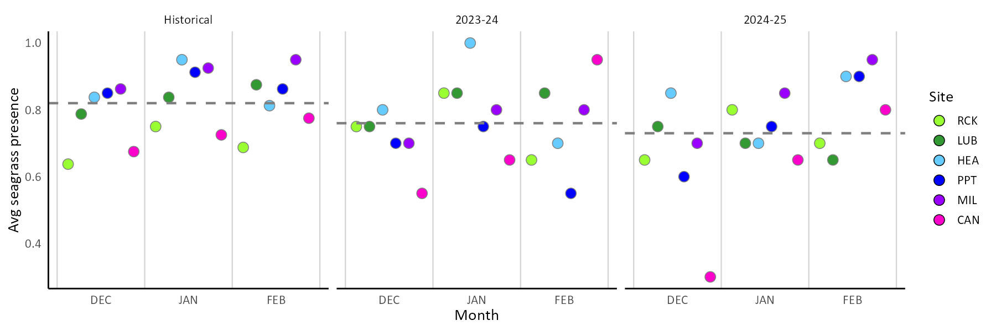
Figure 4: Average seagrass presence within each site and month and time. The historical data is a 4-year average between the 2020-21 and 2023-24 data, inclusive. Presence is assigned a score 1 = seagrass present, 0 = no seagrass present within the quadrat. This score is averaged across sites and times to produce an annual average for each seagrass dataset (December – February), shown as dashed a line.

Seagrass cover
Seagrass cover is a measure of the density seagrass within a quadrat. High leaf densities, and therefore percentage cover, are indicative of healthy seagrass. Leaf density reduces when light is limited or seagrasses are stressed due to other environmental factors.

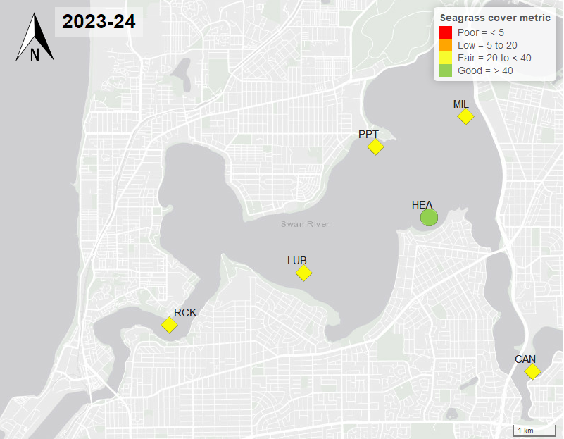
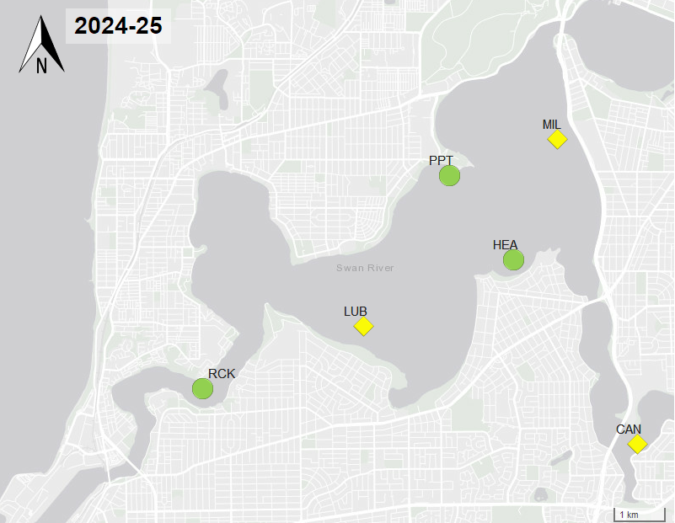
Figure 5: Map of seagrass cover classification for the 2023-24 (top) and 2024-25 (bottom) seagrass seasons.
High presence as well as high cover are an indicator of a healthy productive meadow. Low presence and high cover may indicate healthy disconnected patches of seagrass within a site. For ephemeral species (like H. ovalis), there is a potential to reestablish and vegetatively expand, interconnecting these communities in optimal environmental conditions. Overall, seagrass cover improved in 2024-25 from the previous year, particularly in the RCK and PPT sites which both changed in classification from ‘fair’ to ‘good’ (Figure 5). However seagrass cover was still significantly reduced in 2024-25 (38.5 %, 1.7 ± SE; average midpoint cover) from the historical average (47.1 %, 0.9 ± SE; Figure 6;Supplementary table 5). CAN slightly decreased in cover (2023-24, 25.1 %; 2024-25, 23.0 %). MIL demonstrated the highest overall presence (83.3%), but maintained a relatively low cover (31.2%), indicating that most of the site area had consistently low cover. This season, MIL also exhibited the greatest macroalgal cover and may have experienced light limitation from high turbidity due to high frequencies of SW winds, which combined may have contributed to the reduced seagrass cover observed at the site (Figure 6).

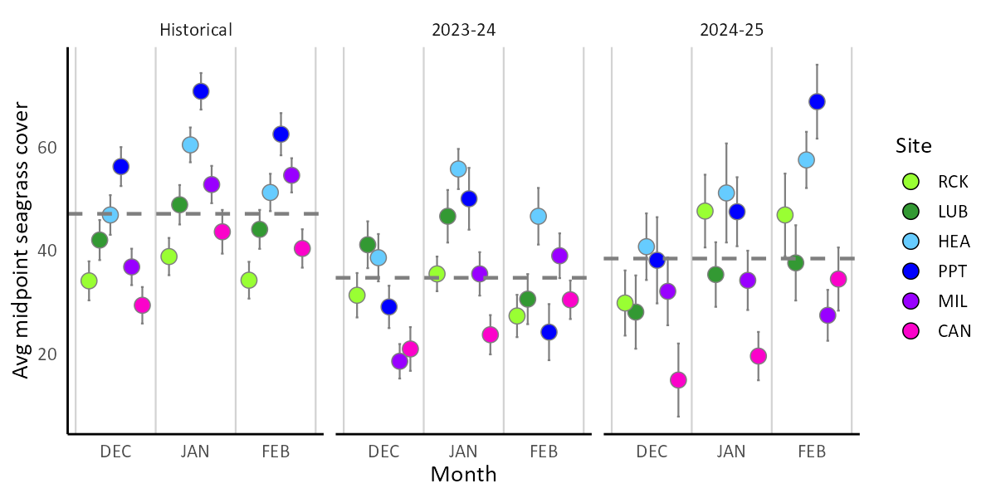
Figure 6: Average midpoint percent seagrass cover, across each site and month, for the 2023-24 and 2024-25 seasons. Historical data is the 4-year average between the 2020-21 and 2023-24 periods, inclusive. Annual average for each seagrass sampling season (December to February), shown as dashed grey line.

Halophila ovalis reproduction
Halophila ovalis as a dioecious seagrass, reproduces sexually with male and female flowers on separate individuals or asexually through clonal vegetative growth. Pollination between flowers occurs via hydrophily (water-mediated pollination), with female flowers producing a fruit body generally containing 1-20 seeds. While vegetative growth supports local population expansion, sexual reproduction through seed germination facilitates short distance dispersal, enhances colonisation of new areas, and contributes to genetic diversity.
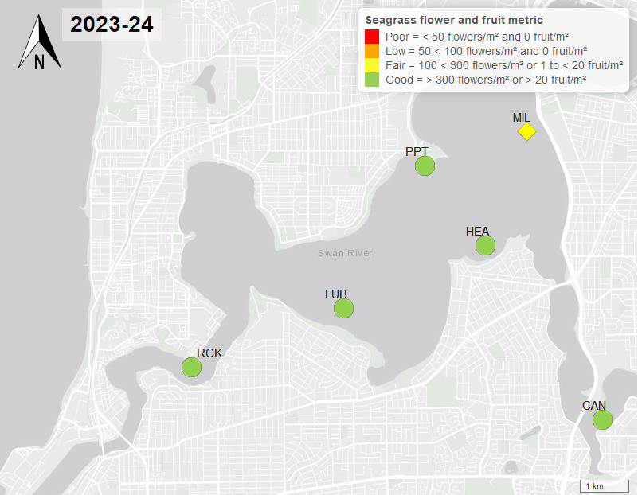
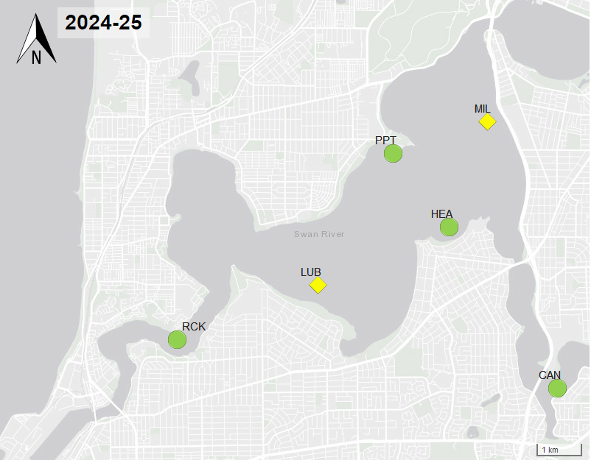
Figure 7: Map of seagrass flower and fruit classification for the survey in the 2023-24 (top) and 2024-25 (bottom) seagrass season.
Seagrass reproduction performed ‘fair’ at the MIL and LUB sites and ‘good’ at all other sites in 2024-25 (Figure 7). While the average annual flower densities were higher in 2024-25 (454.97 flowers m², 41.475 ± SE), than the previous year (454.97 flowers m², 41.475 ± SE), and the historical average (454.97 flowers m², 41.475 ± SE, Figure 8a). The fruit densities were low in 2024-25 (119.01 fruit m², 23.6 ± SE), reducing from 2023-24 (154.11 fruit m², 26.47± SE) and the historical average (193.08 fruit m², 17.53 ± SE, Figure 8b). The reduction in reproductive performance in LUB from ‘good’ in 2023-24 (145.1 fruit m², 62.26 ± SE) to 2024-25 (5.72 fruit m², 62.26 ± SE) was due to a large reduction in the number of fruits produced at this site.
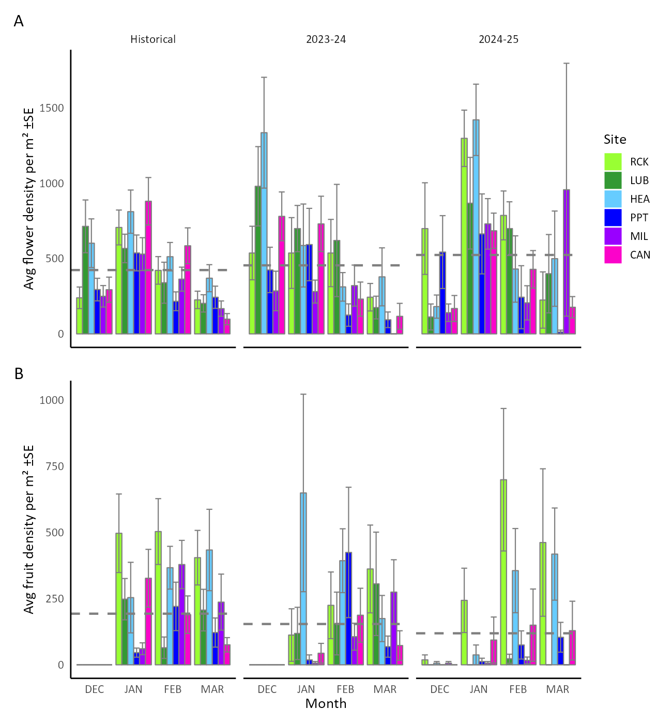
Figure 8: Average seagrass: A) flower density (no. flowers per m²) and; B) fruit density (no. fruit per m²) within each site in the 2023-24 and 2024-25 seasons and for the overall historical data (3 years between 2021-22 and 2023-24). Annual average for each seagrass sampling season (December – March) shown as dashed line.

Seagrass biomass
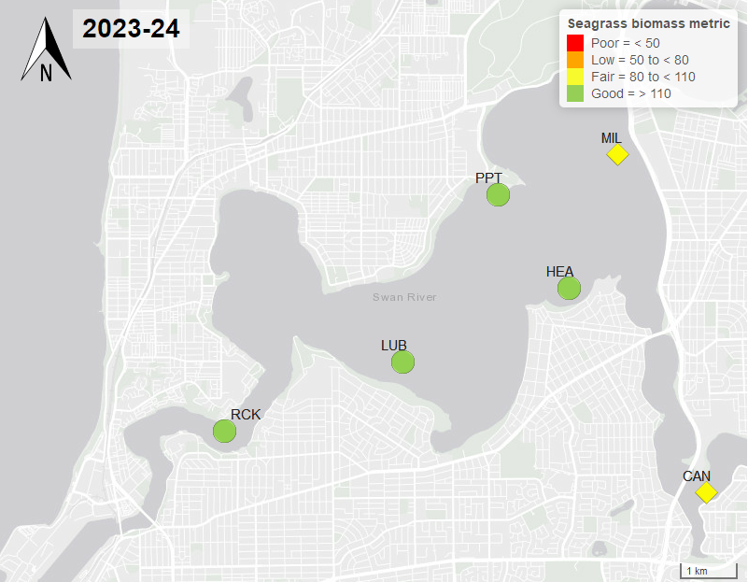
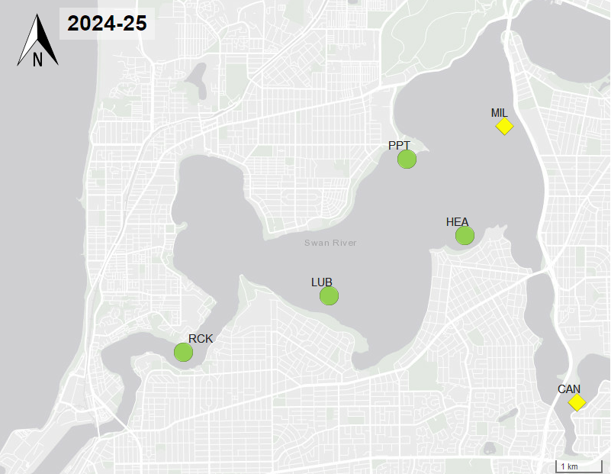

Figure 9: Map of seagrass total biomass classification for the survey in the 2023-24 (top) and 2024-25 (bottom) seagrass seasons.
Biomass is a measure of total seagrass tissue present (leaves, roots, rhizomes, fruit and flowers) per unit area. In optimal conditions, biomass can be higher in shallow areas where irradiance is increased allowing for higher leaf productivity and greater carbohydrate storage capabilities. Tracking biomass over time can assist in identifying how environmental stressors such as turbidity, nutrient loads, or temperature events can impact seagrass growth. The ratio of above ground (leaves, stems, and reproductive structures) to below ground (roots and rhizomes) biomass can inform on how seagrass communities are allocating their resources to either energy production and reproduction (above ground biomass) or energy storage (below ground biomass).
There were no significant differences in biomass, with only a slight increase from 2023-24 (128.69 g dry weight/m², 4.9 ± SE) to 2024-25 (130.02 g dry weight/m², 4.7 ± SE; Supplementary table 10). However, biomass for both MIL and CAN sites was lower than average in 2023-24 (89.98 g dry weight/m², 8.6 ± SE, and 109.16 g dry weight/m², 9.1 ± SE, respectively) and 2024-25 (90.48 g dry weight/m², 6.4 ± SE, and 81.08 g dry weight/m², 6.5 ± SE, respectively); with both sites performing ‘fair’ in the total biomass index, indicating lower seagrass health consistently over the last 2 years (Figure 9; Figure 10). Both MIL and CAN had high levels of macroalgae abundance in 2024-25 which may have contributed to these low biomass results.

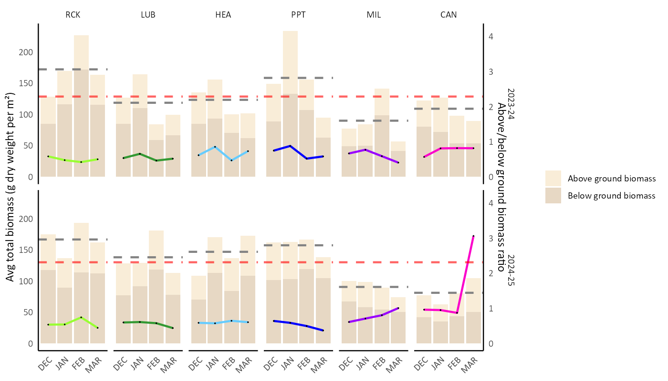
Figure 10: Seagrass above and below ground biomass combined to present total biomass within each site, for each month measured in 2023-24 (top) and 2024-25 (bottom). The average total biomass for each seagrass site is shown in dark grey, refer to left y-axis. The red line represents the yearly average. The coloured line graphs indicate the above/below ground ratio within each site, refer to right y-axis.

Ancillary performance measurements

Leaf density
Leaf density declined in 2024–25 (5337.18 leaves m⁻², 202 ± SE) compared to 2023–24 (6038.40 leaves m⁻², 217 ± SE), with both years falling below the historical average of 7445.08 leaves m⁻², 158 ± SE (Figure 11). Leaf density varied considerably among months and sites; however, RCK (6827.39 leaves m⁻², 406 ± SE) remained consistently above the 2024–25 annual average, while MIL (3929.25 leaves m⁻², 257 ± SE) and CAN (4209.04 leaves m⁻², 453 ± SE) were consistently below it. In 2024–25, both benthic light and global solar exposure declined, potentially impacting seagrass leaf growth. Under low-light conditions, seagrasses often reduce leaf densities as part of a physiological response aimed at improving light-harvesting efficiency⁵.

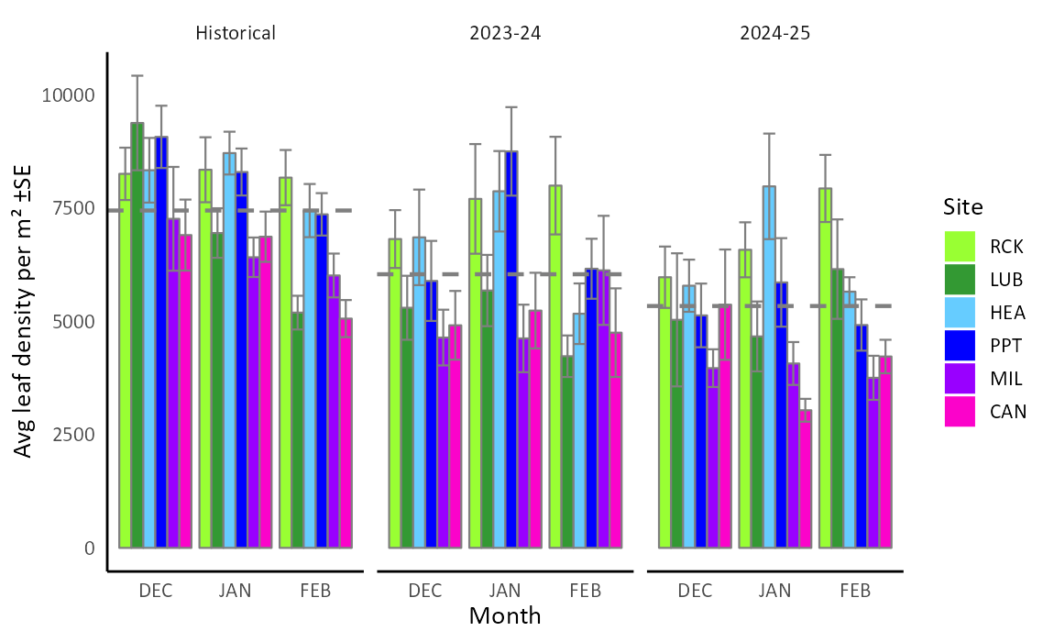
Figure 11: Average seagrass leaf density across each site and month, for the 2023-24 and 2024-25 seasons. Historical data is the 4-year average between the 2020-21 and 2023-24 periods, inclusive. Annual average for each seagrass sampling season (December to February) is shown as dashed grey line.

Seed density
Seed density varied substantially among months and sites (Figure 12). Although the 2024–25 season recorded a slightly higher overall mean seed density (1108.42 seeds m⁻², 264 ± SE) compared with 2023–24 (805.49 seeds m⁻², 143 ± SE), the 2024–25 average was strongly influenced by consistently high densities at RCK (3877.07 seeds m⁻², ± 1291 SE). In contrast, seed production during 2023–24 was more evenly distributed across sites throughout the season. During 2024–25, seed densities remained low at both MIL (121.17 seeds m⁻², 76 ± SE) and LUB (54.6 seeds m⁻², 39 ± SE), producing a ‘fair’ classification in the reproductive indices. MIL exhibited peak flower productivity in March, suggesting delayed seed production at this site in 2024–25 which was not captured within the monitoring period.
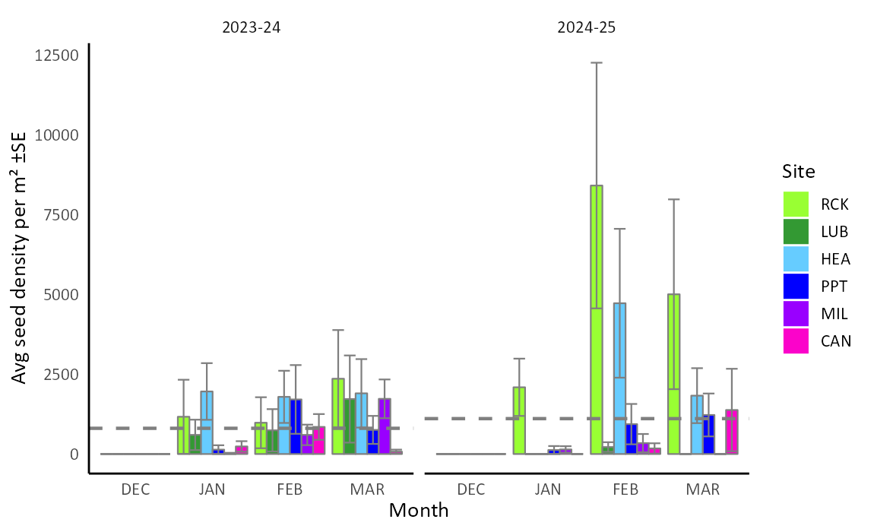
Figure 12: Average seagrass seed density within each site taken across 2 years of observation. Annual average for each seagrass sampling season (December – March) shown as dashed grey lines.

Environmental conditions

Noteworthy environmental conditions
In 2025, Western Australia experienced one of its most severe marine heatwaves on record. Beginning in late 2024 and intensifying into early 2025, ocean temperatures rose 3–5°C above average across the northwest and along much of the WA coastline. The Australian Institute of Marine Science described this event as the longest, largest and most intense heatwave experiences by the WA marine environment
The 2024-25 season:
- The mean maximum temperature in Perth CBD was 0.7 °C above the summer average of 30.9 °C.
- The daily maximum temperatures in the CBD ranged from 21.7 °C to 43.6 °C (the highest temp occurred on the 20th Jan 2025)
- Summer and Spring rainfall were below average.
- Total rainfall for Perth in Summer was 9.2 mm, which is 24% less than the long-term average (38.9 mm).
- Spring mean daily maximum temperature in Perth CBD was 24.5 °C, which is slightly above than the long-term average of 23.6 °C.
- In spring, total rainfall in the larger Perth area was below average, ranging between 52-89% of the total average.
The 2023-24 season:
- Summer temperatures in the Perth metropolitan area were 1.7 °C above the long-term average of 30.9 °C.
- The hottest recorded day was 42.9 °C on the 18th of February 2024
- The 2023 spring maximum temperatures at 10 weather stations across Perth were the highest on record over a 79-year period.
- In spring, Perth Metro recorded a maximum temperature of 39.0 °C (23rd November 2023) with the highest recorded spring temp of 40.4 °C recorded on the 16th of November 2019.
- Summer and Spring rainfall were below average.
- The summer total rainfall for Perth Metro was 6.8 mm, significantly less than the long-term average of 38.9 mm
- The spring 2023 season in the Perth metropolitan area recorded only 56.8 mm, considerably lower rainfall than the long-term average of 147.0 mm.
- Spring rainfall in the greater Perth metropolitan area received 58-80 mm and the Perth Hills 100-140 mm.

Rainfall
Freshwater input after rainfall events can impact estuarine seagrass communities⁹. High rainfall can lower salinity, increase light attenuation due to elevated turbidity and sediment loads, and flush nutrients into the system that lead to algal growth which competes with seagrass for light and nutrient resources in the water column. Conversely, periods of low rainfall can lead to elevated salinity and reduced nutrient availability and higher saltwater intrusion from the marine environment. Rainfall in the Perth metro regions in both 2023-24 and 2024-25 was below average in spring, summer, and during the seagrass sampling period, indicating a drier spring/summer (Figure 13).
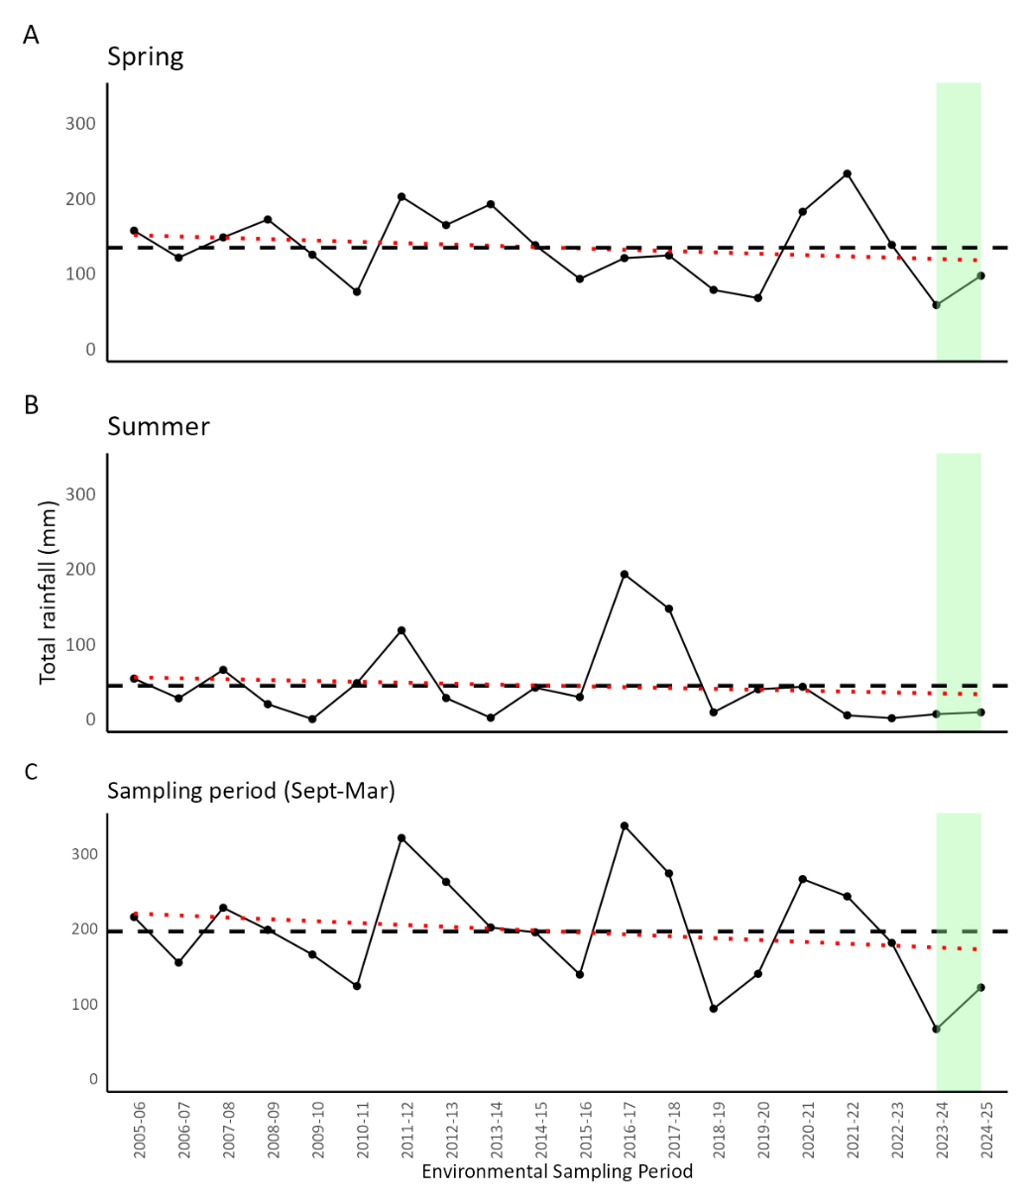
Figure 13: Average total rainfall for: A) Spring period (September to November); B) Summer period (December to February); and C) September-March. Environmental sampling period was selected to reflect the seagrass season, and the total rainfall encompassed within each season recorded at Perth Metro from 2005-06 through to 2024-25, current reporting period highlighted in green. Red line represents the trend line within the data period. Data from Bureau of Meteorology.

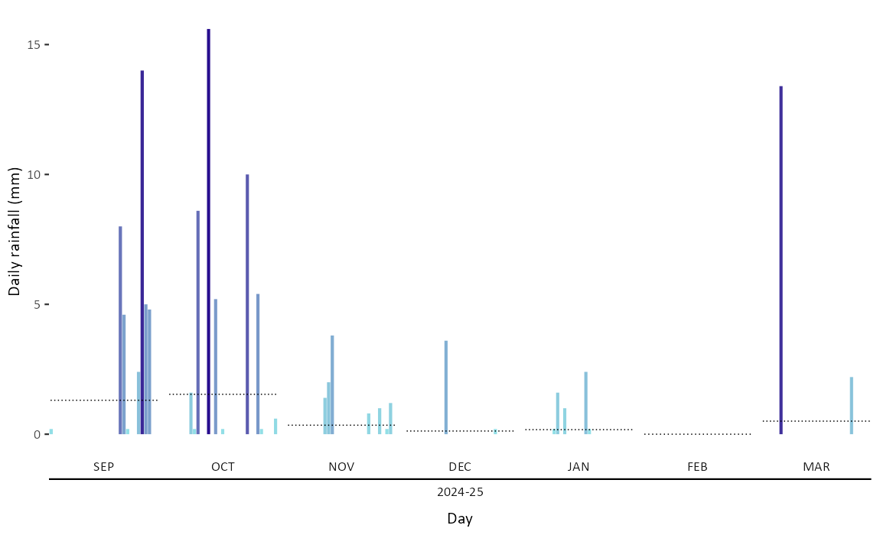
Figure 14: Total daily rainfall (mm) within each month (September to March) recorded at Perth Metro in 2024-25. Average monthly rainfall is shown as black line. Data from Bureau of Meteorology.

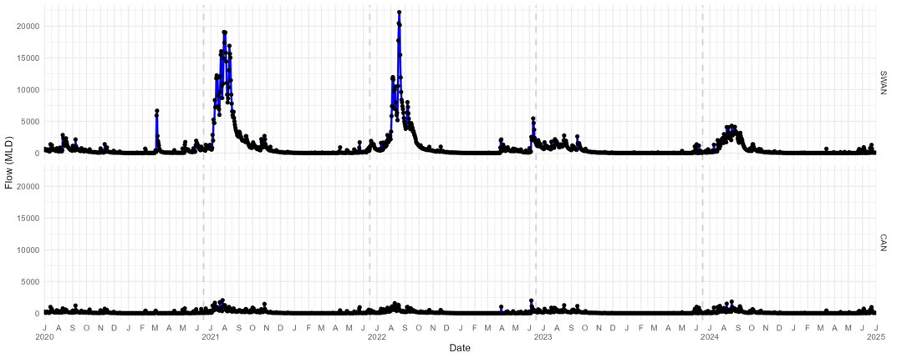
Figure 15: Catchment inflow data capturing water flow (megaliters per day) into the Swan (top) and Canning (bottom) river systems, using the data from the Swan Canning Estuarine Response Model (SCERM44; DBCA).

Tidal variations
Tidal fluctuations influence the depth of the water column above seagrass meadows at any given time. High tides increase light attenuation throughout the water column particularly when co-occurring with high turbidity. Tides can also act as a thermal buffer for high air temperatures during heat waves as deeper water reduces the amount of advection of high air temperatures through the water column to the seagrass meadow. Tides were elevated throughout 2024–25 (Figure 16), with mean levels of 91.77 cm at Barrack Street and 87.8 cm at Fremantle. From October 2024 until March 2025 tides were higher than the historical average. Tides were consistently high in January, reaching an average of 105.3 cm at Barrack Street (Figure 17). The high January tides are likely due to low pressure storm surge associated with the passage of Tropical Cyclone Sean in northern Western Australia (Supplementary Figure 4).
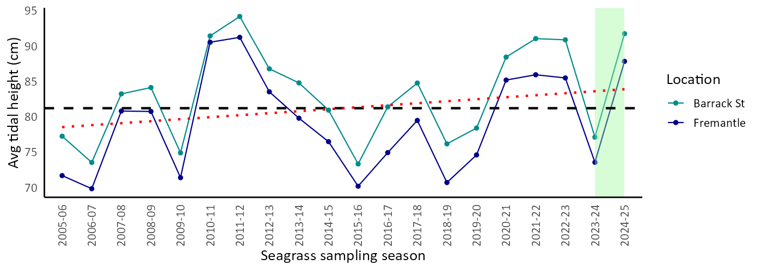
Figure 16: Average tidal height (cm) recorded at two locations: Barrack Street Jetty and Fremantle, within each sampling season (September to March). Recorded across 20 years, from 2005-06 to 2024-25, reporting period highlighted in green. Black dashed line is the total average of all years across both locations, red dotted line is the tidal trajectory over the 20-year period using a linear regression model. Data compiled from the Department of Transport.
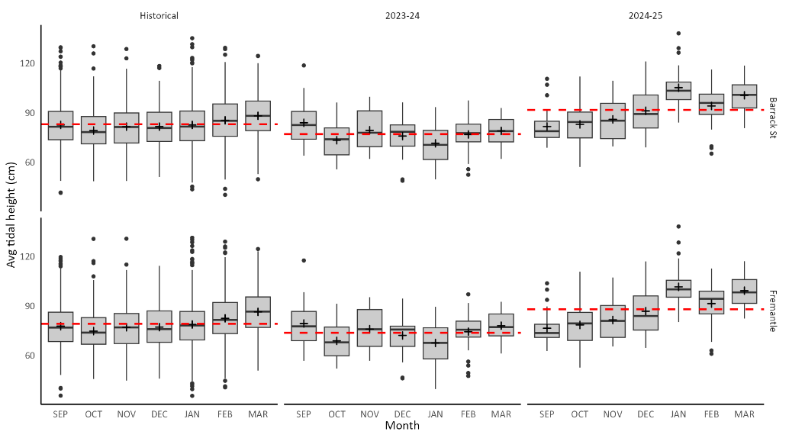
Figure 17: Average tidal height (cm) recorded at two locations: Barrack Street Jetty (Perth) and Fremantle, from September to March, across historical (20 years 2005-06 to 2023-24), 2023-24 and 2024-25. Red dashed line is the average tide height within each year at each location. Represented within the boxplot; median value shown in black line, the mean value for each time data point represented as ‘+’. Data obtained from Department of Transport.

Salinity
Salinity in the Estuary can decrease substantially during periods of heavy rainfall, which can be intensified by increased water flow derived from the Swan Canning catchment. Seagrass meadows at downstream sites, which experience relatively stable salinities due to their proximity to the ocean, have lower adaptive capacity and therefore exhibit reduced resilience to sudden changes in salinity. In contrast, seagrass at upstream sites is naturally exposed to greater salinity fluctuations and can tolerate greater shifts in salinity levels. Salinity data shown below is collected at nearby water quality monitoring sites (data taken from the top two metres of the water column). While not taken directly at the seagrass sites, these measurements reflect conditions impacting the nearby shallow seagrass meadows.
Average salinity across all sites was lower in 2024–25 (32.02 ppt, 0.2 ± SE) compared with 2023–24 (34.21 ppt, 0.2 ± SE). However, salinity variability was greater in 2024–25 relative to the previous year (for example, BLA recorded 33.49 ppt, 0.34 ± SE in 2024–25 compared with 34.78 ppt, 0.24 ± SE in 2023–24; Figure 18). However, salinity variability in both years is minimal and is unlikely to have a measurable effect on seagrass condition.
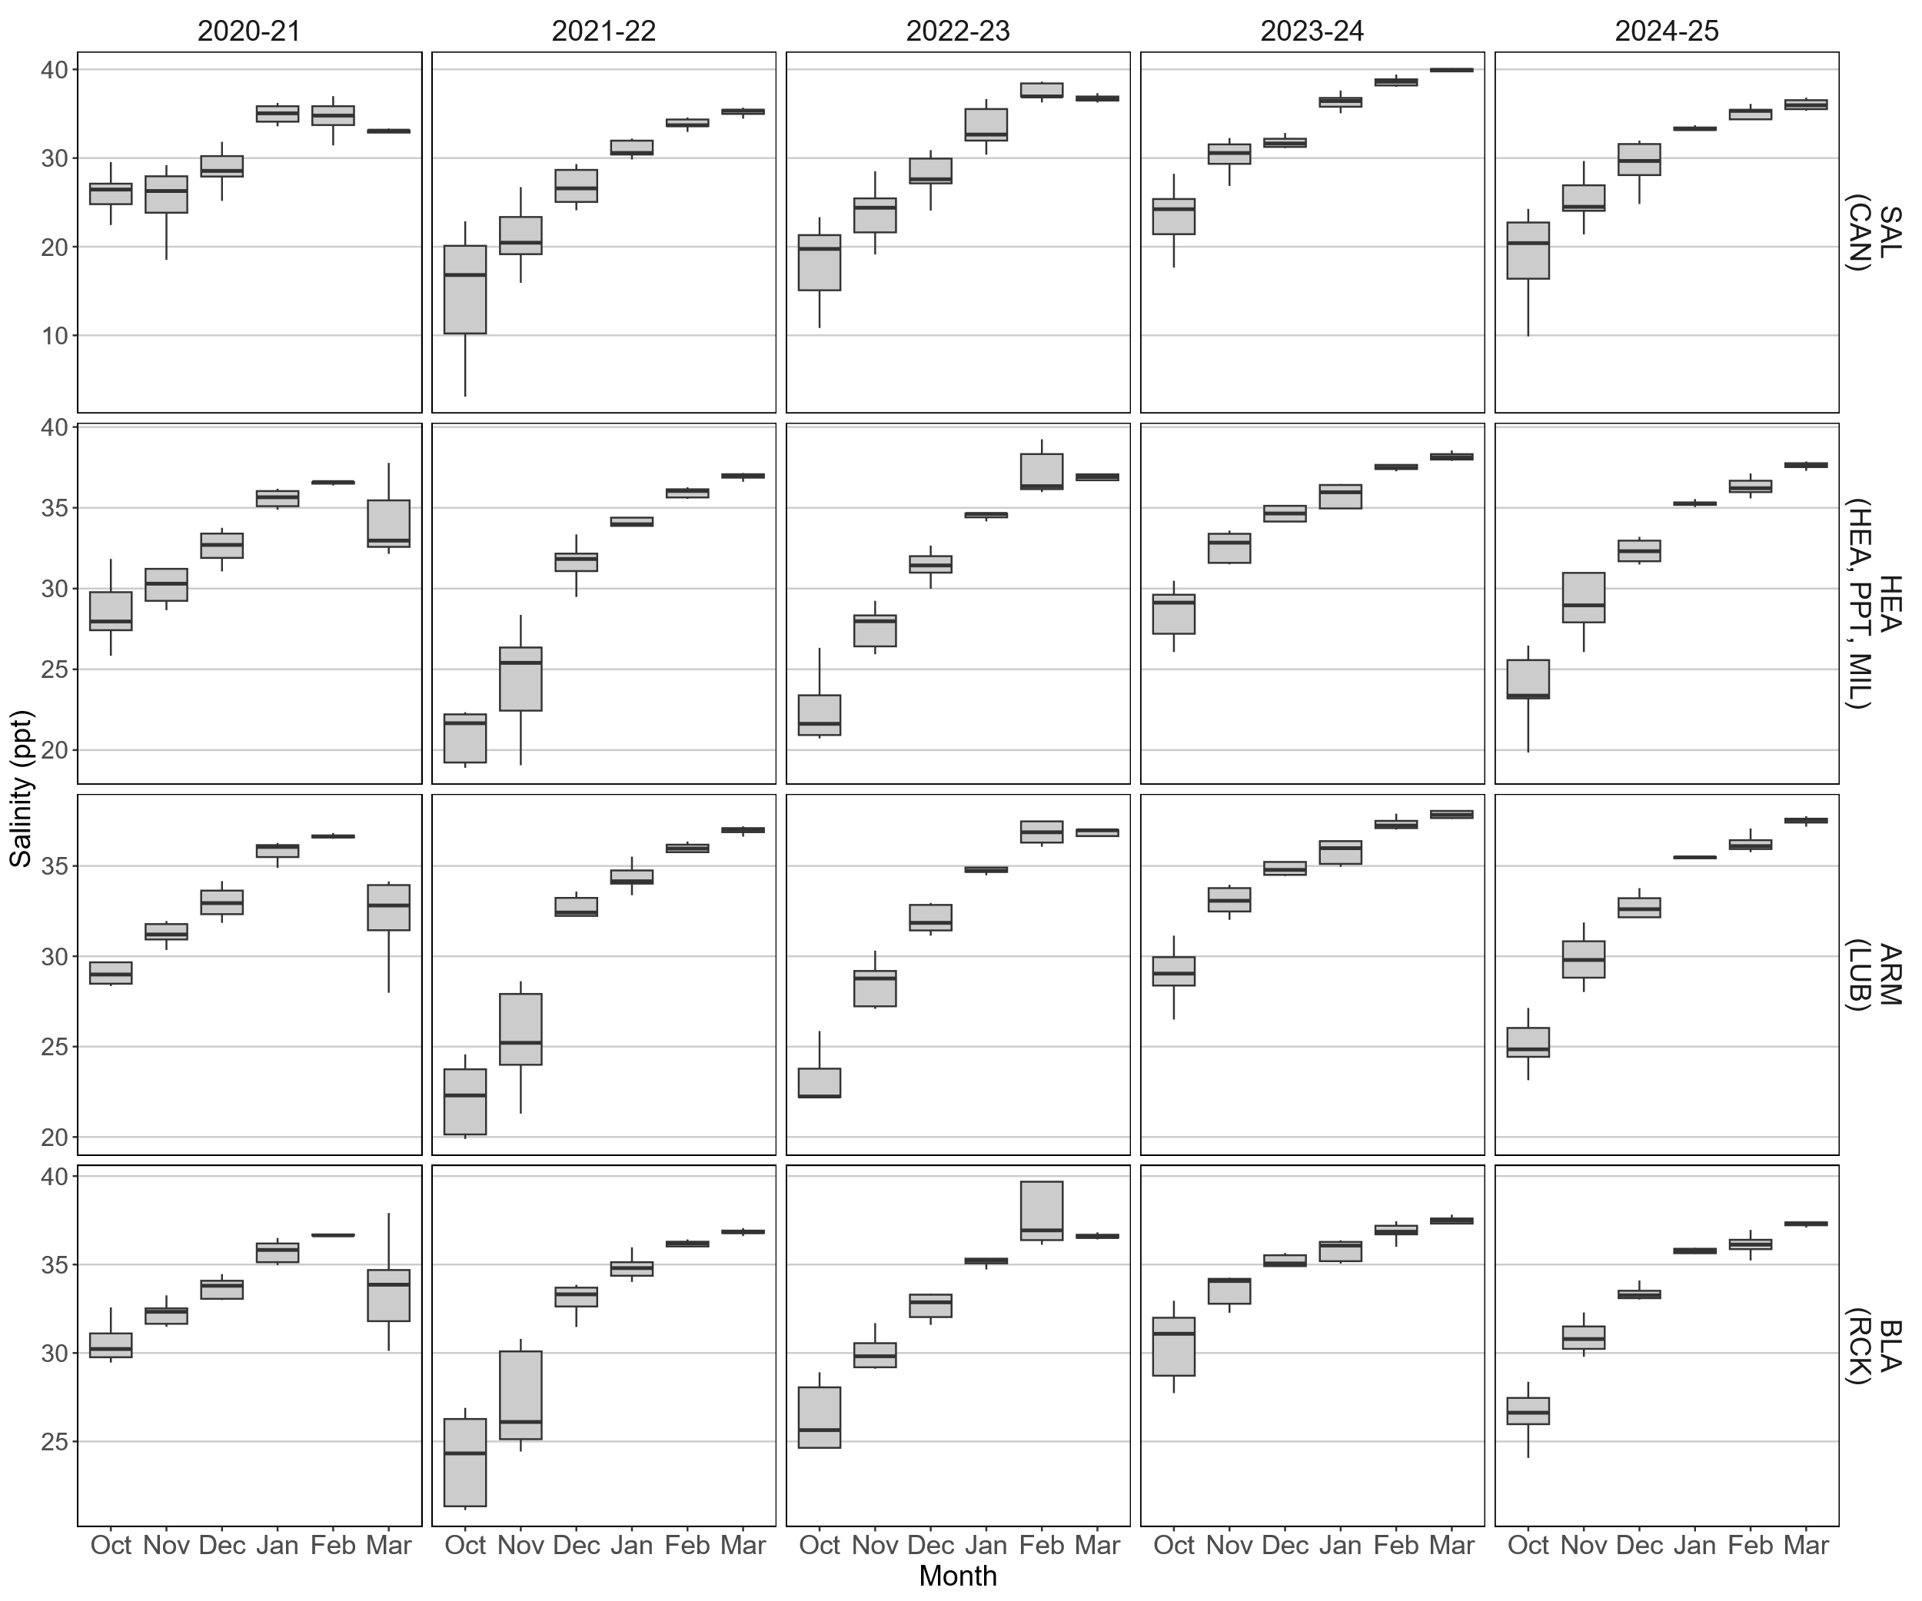
Figure 18: Boxplots of monthly salinity readings in the top 2 metres in the water column at water quality sites near seagrass monitoring sites. Relevant seagrass sites are shown in brackets next to monitoring site.

In-situ water temperature
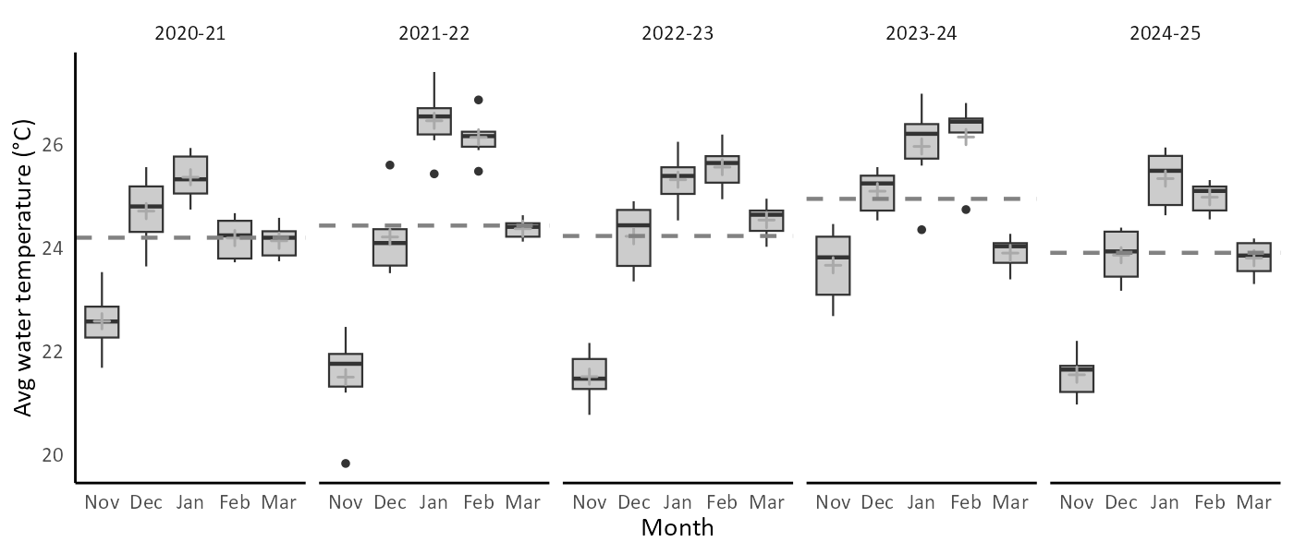
Figure 19: Average water temperature per year, recorded over 5 years (between 2020-21 and 2024-25), from November to March. Annual average for each seagrass sampling season is shown as dashed grey lines.
Seagrass biomass production is optimal within a certain temperature range; stress and a reduction in seagrass productivity can occur if temperature shifts beyond the bounds of the optimal range. Water temperature across all sites in the Estuary was cooler in 2024–25 (average 23.9 °C; Figure 19) compared with previous years, this is despite the extreme heatwave affecting northern Western Australia. During the January heatwave, the mean water temperature across all sites was 25.3 °C in 2025, lower than the 26.0 °C recorded in January 2024 (Figure 20). These cooler temperatures are likely due to the thermal buffering of the high tides present throughout January 2025. In contrast, 2023–24 experienced record low tides that reduced the amount of water available to absorb atmospheric heat (Figure 16).

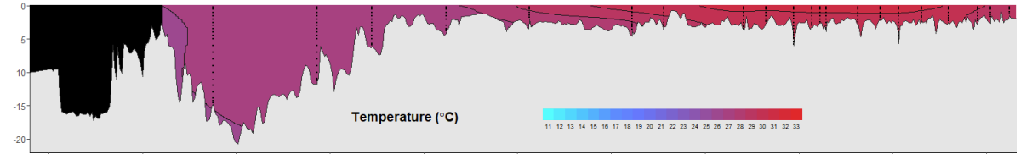
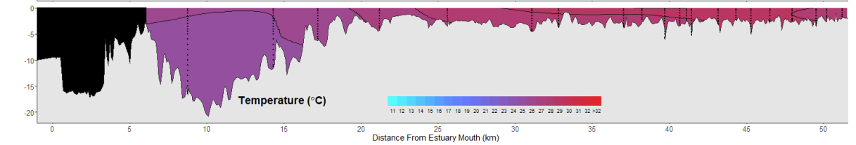
Figure 20: Central estuary water temperatures on: Top - 22/01/2024 and; Bottom – 20/01/2025. Data is collected from sites located at mouth of estuary (left) to upstream in West Swan. The January 2025 temperature data was captured during the marine heatwave period.

Air temperatures
Air temperatures across the Perth metropolitan area in 2024–25 were slightly above the long-term 20-year average during both Spring and Summer (Figure 21); and considerably cooler than 2023-24. Air temperatures are closely linked with water temperatures in the lower estuary.
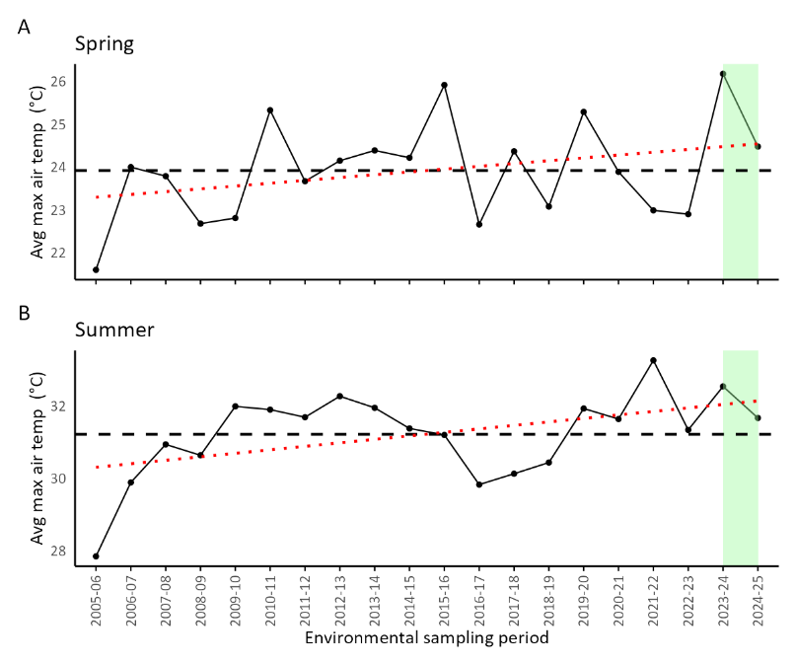
Figure 21: Average yearly max temperature for: A) Spring period (September to November); B) Summer period (December to February). Data recorded at Perth Metro from 2005-06 through 2024-25, current reporting period highlighted in green. Data from Bureau of Meteorology.

Global solar exposure
Global solar exposure is the total amount of solar energy received on a horizontal surface over a given period, in megajoules per square metre. It is primarily determined by the sun’s position in the sky driven by latitude, season, and time of day, as well as the degree of atmospheric interference such as cloud cover or haze (http://www.bom.gov.au). For photoautotrophs such as seagrasses, the availability of light is a fundamental driver of photosynthesis, influencing their capacity to produce carbohydrates. Variations in solar exposure from year to year, can impact seagrass productivity and overall performance. Solar exposure was lower in the 2024-25 sampling period compared to the previous year, however the level in 2024-25 was only slightly less than the 20-year average (Figure 22).
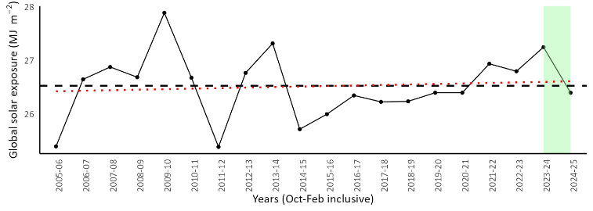
Figure 22: Average daily global solar exposure is a recording of the downward irradiance over Australia, derived from a sequence of satellites. This graph shows the recorded solar exposure within each sampling season (October to February), across 20 years 2005-06 to 2024-25, reporting period highlighted in green. Dashed line is the total average of all years across both locations. Red line represents the trend line within the data period. Data from Bureau of Meteorology’s daily global solar exposure model.

Benthic light
Light availability is a key driver of seagrass biomass, productivity, abundance, and growth in deeper habitats¹¹. This is particularly true for H. ovalis, which has a low tolerance to light limitation, with studies indicating it may survive only around one month under complete light deprivation. Across all sites, average benthic light levels were lower in 2024–25 compared with 2023–24; most likely due to the low tides recorded in 2023–24 increasing benthic light exposure in shallow zones (Figure 23). Throughout the 2024–25 season and at all sites, benthic light availability remained above the 80% threshold associated with reduced shoot density¹¹. Light availability at the CAN site was low in both 2023-24 and 2024-25 compared with other sites, most likely associated with tannin-rich water flow (Figure 24).
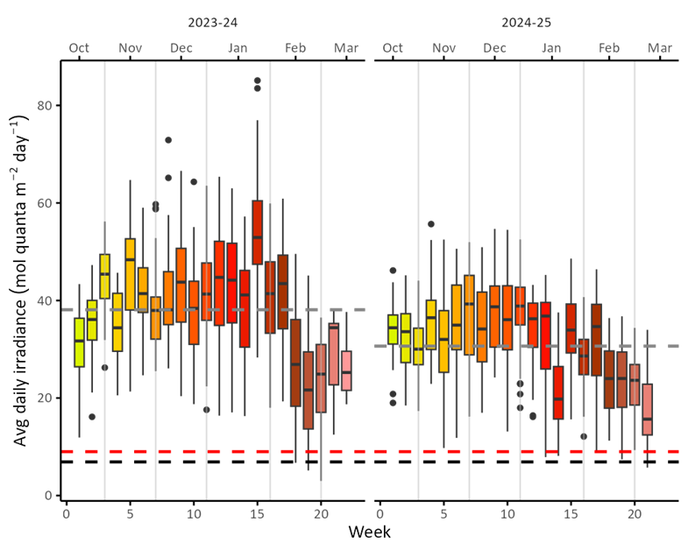
Figure 23: Daily average benthic irradiance recorded per week, during the 2023-24 and 2024-25 seagrass monitoring seasons. Weeks are inclusive of the 3rd Monday in October to 3rd Sunday in March. Displayed on the plot are the potential light levels necessary to ensure H. ovalis is 80% protected against reductions in shoot density (red dashed line) or growth rate (black dashed line)*, dashed grey line is the average daily irradiance calculated per season.

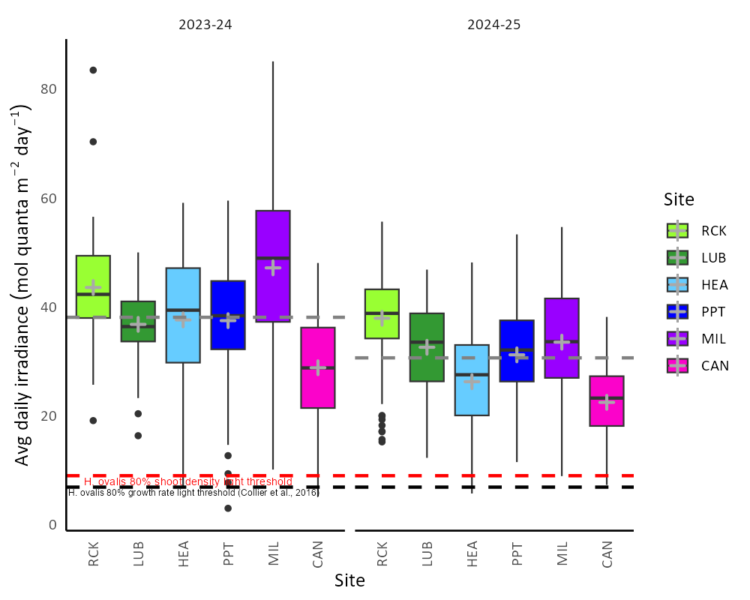
Figure 24: Site-based average daily benthic light, recorded during the 2023-24 and 2024-25 seagrass monitoring seasons (3rd Monday in October to 3rd Sunday in March). Dashed grey line is the average daily irradiance across all sites for each year. Represented by the boxplot is the median value shown as the black crossbar and the mean value for each site as ‘+’. Displayed on the plot are the light thresholds necessary to ensure H. ovalis is 80% protected against reductions in shoot density (red dashed line) or growth rate (black dashed line) at cool temperatures (~23°C)¹¹.

Wind speed and direction
Wind speed and direction impact seagrass by generating wind waves that agitate bottom sediments and attenuate light when entrained in the water column. The degree of light attenuation caused by resuspension of bottom sediments is a function of bottom sediment grain size, site aspect, wind speed, and wind direction. For example, wind waves generated from the typical afternoon south-westerly breeze has a minimal impact at LUB due to the site being on the southerly side of the estuary. Conversely, at PPT and MIL there is a longer fetch for wind waves generated by a south-westerly breeze, producing high energy and resuspending bottom sediments through the shallow areas of these sites. CAN and to a lesser extent MIL both have a higher amount of small grain sized silty sediments due to their upstream location in the estuary. This means that turbidity from sediment resuspension at CAN and MIL is greater and persists longer than sediments resuspended at RCK and LUB which have a higher proportion of larger grain sized calcareous marine derived sediment. During the 2023–24 season, strong wind events exceeding 9 m s⁻¹ occurred at frequencies greater than 15%, with wind directions alternating predominantly between easterly and south-westerly. Strong easterlies were as common as strong south-westerlies in November and December of 2023-24 which was somewhat unusual. Whereas, the typical light easterly and strong south-westerly ‘sea-breeze’ pattern that is common in Perth, was more evident in the 2024-25 season (Figure 25).
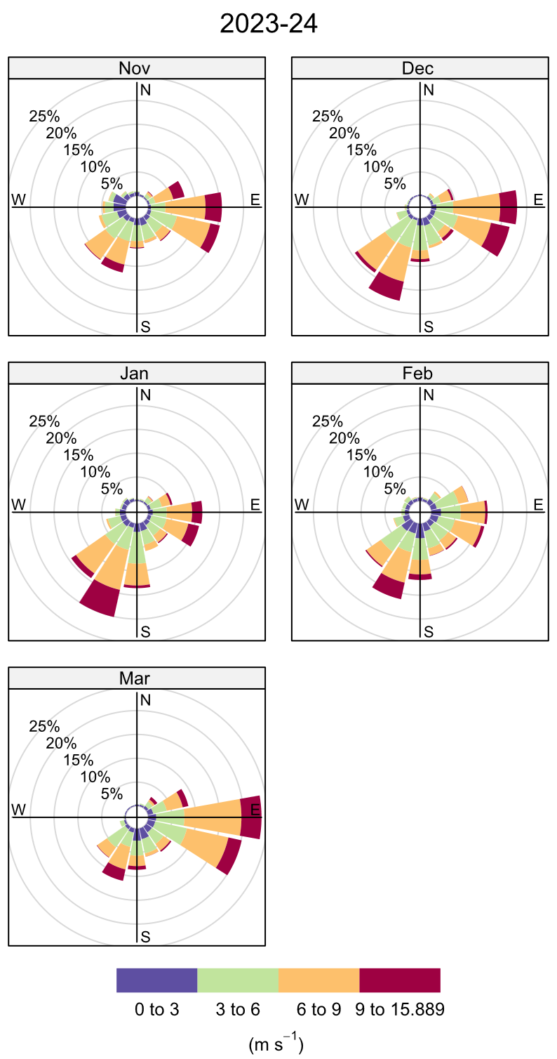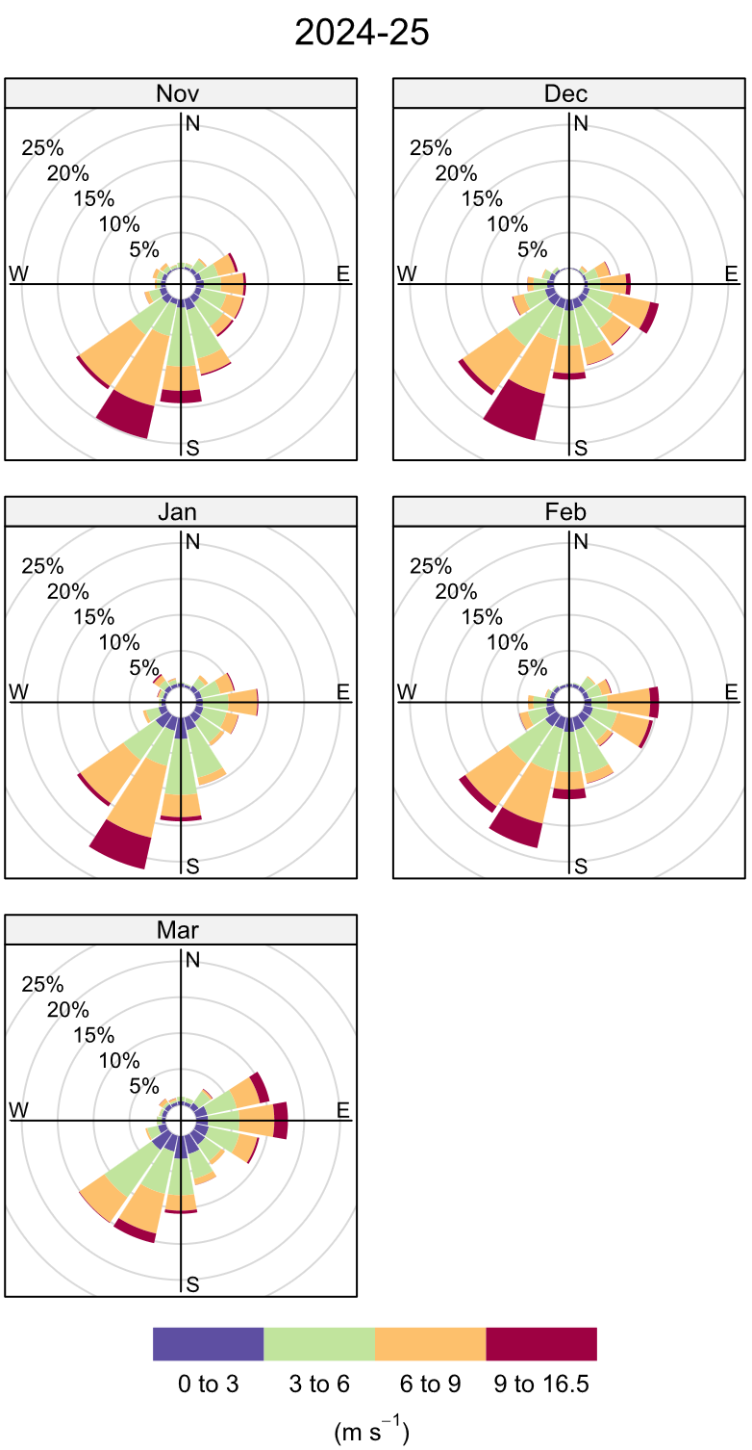
Figure 25: Windroses, data from Melville Water (Station number 9091) for each month, recorded over 2 seasons (2023-24 and 2024-25). Direction of the bars show the direction of the wind, recorded every minute in metres per second. The circles around the image represent the various percentages of occurrence of the winds (e.g. bars marked at the 10% ring indicates 10% of observations were blowing from that direction). Data from Bureau of Meteorology.

Seagrass pressures

Macroalgal cover
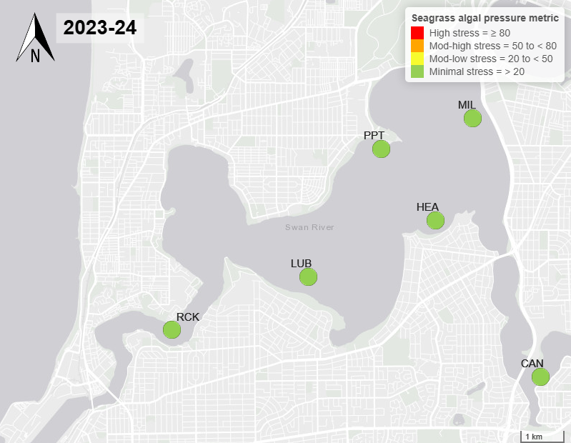
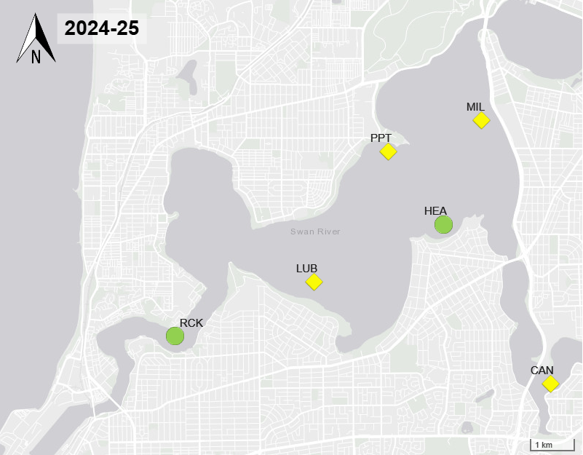
Figure 26: Map of seagrass macroalgae pressure indicator for the survey in the 2023-24 (top) and 2024-25 (bottom) seagrass seasons.
Macroalgae is a common component and competitor with seagrass in the Swan–Canning Estuary, and opportunistic genera such as Chaetomorpha, Cladophora, and Hypnea are capable of rapid growth when environmental conditions become favourable. Elevated water inputs from urban and catchment zones, carry nutrients (particularly, nitrogen and phosphorus) and can stimulate excessive macroalgal production and growth throughout the Estuary. Macroalgae can exert significant pressure on seagrass communities through shading and competition for nutrients in the water column. Macroalgae was high and dominated by fast growing Hypnea species in 2024-25 (Figure 28). Drailer et al., 2012 states that Hypnea musciformis is an opportunistic macroalga capable of physiologically responding to excess nutrients at rates equal to the Ulva spp. (Observed in nearshore regions of Maui that are affected by anthropogenic nutrient enrichment). Given this high level of opportunistically, Hypnea in high abundances can exert a high level of pressure on seagrass communities in the Estuary impacting a range of seagrass health metrics.
The average macroalgal cover increased in 2024-25 (21.9 %, 1.23 ± SE), representing a noticeable rise compared to the historical mean of (13.15 %, 0.47 ± SE). This increase in algae was particularly driven by the MIL site which recorded the highest macroalgal cover (36.7 %, 3.4 ± SE), followed by CAN (25.9 %, 3.4 ± SE). In 2023–24, MIL also exhibited the highest macroalgal densities (19.4 %, 2.8 ± SE; Figure 27) comparative to all other sites. These high levels of macroalgae may be attributed to elevated nitrogen concentrations in the water column, combined with reduced water flow, as observed in CAN during 2024–25 (see Supplementary figure 3; Figure 15). Limited water movement can increase nutrient residence times, promoting conditions that favour macroalgal growth.

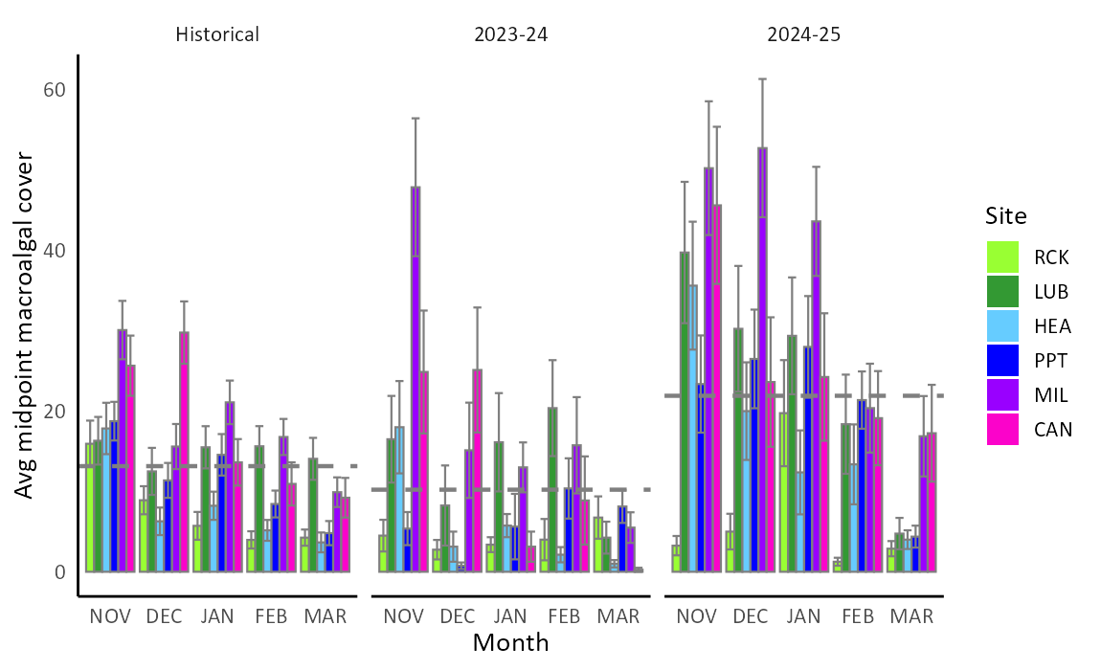
Figure 27: Average midpoint percent macroalgae cover, across each site and month, for each of the Historical, 2023-24 and 2024-25 seasons. Historical data is the 4-year average between the 2020-21 and 2023-24 periods, inclusive. Annual average for each seagrass sampling season (November – March) is shown as dashed grey line.

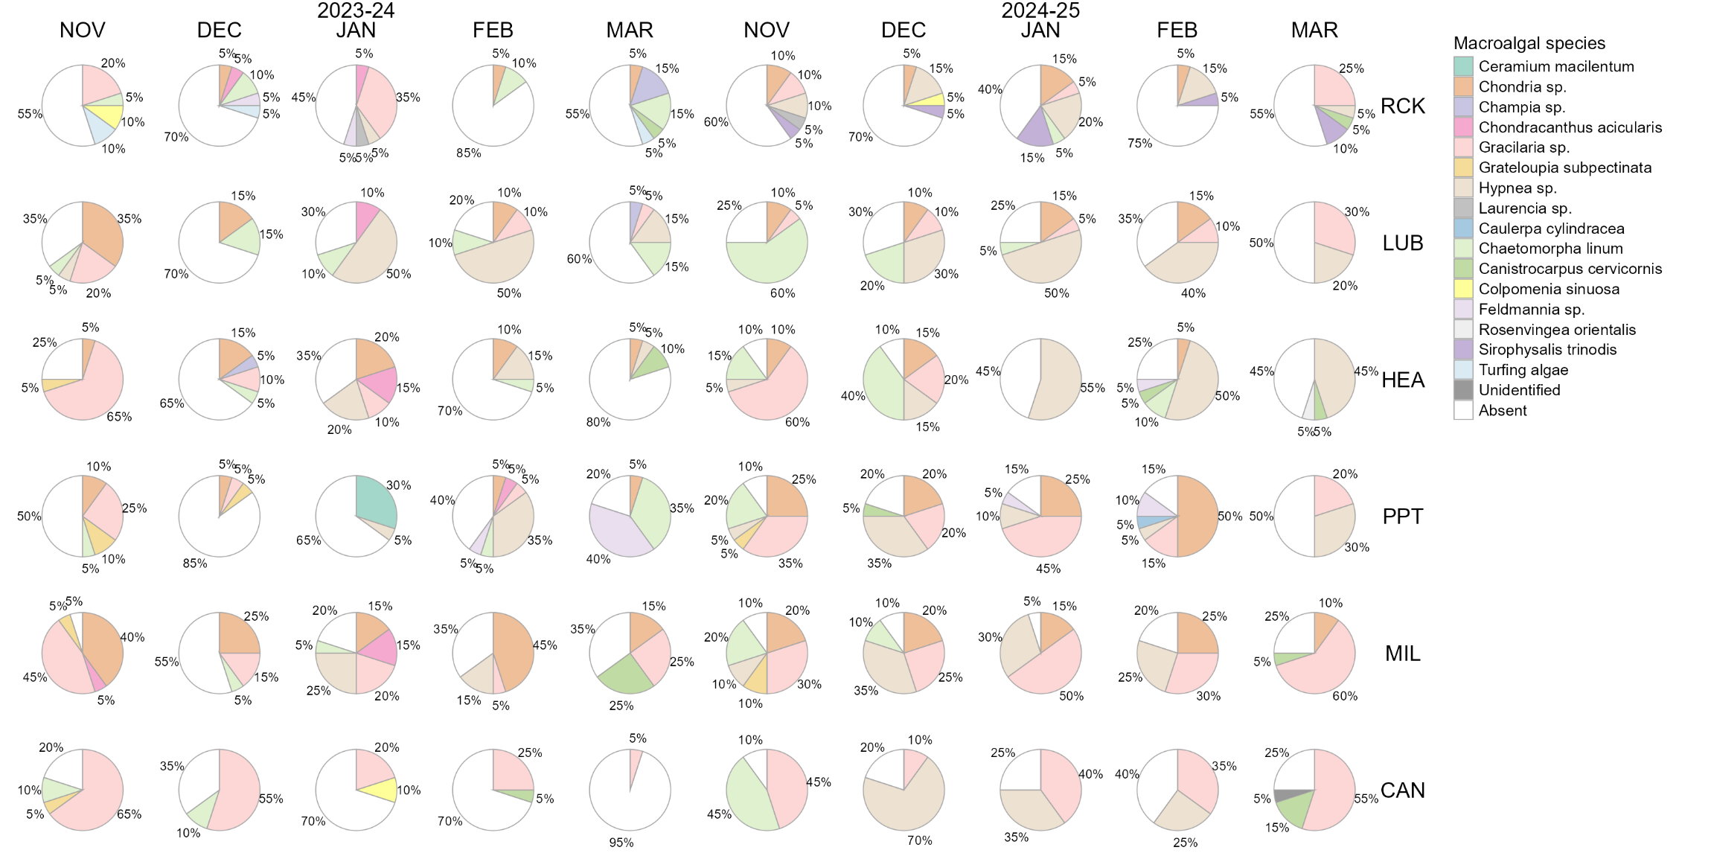
Figure 28: Pie graph representing the one macroalgal species that was recorded in highest abundance within each quadrat and representing the total abundance of algae at each site and time. Recorded during the 2023-24 and 2024-25 seagrass monitoring seasons at each site from November to March.

Ancillary pressure measurements

Batillaria australis density
Batillaria australis is a marine gastropod that has been introduced into the Swan-Canning Estuary, originating from the east coast of Australia (circa 1954). It is now highly abundant in the system yet its impact on the seagrass community is mostly unquantified. Gracilaria spp. can often be affixed to B. australis shells which can provide a substrate for macroalgal growth in locations where a substrate might otherwise not be present¹³. Research on bioturbation, root displacement, bacterial, sediment oxygenation, sulfide intrusion and feeding impacts of B. australis within the seagrass rhizosphere is presently limited.
Batillaria australis densities declined from 2023-24 (807.26 m⁻², 60.9 ± SE) to 2024-25 (652.27 m⁻², 39.58 ± SE; Figure 29). However, the density in 2023–24 was only slightly higher than the five-year average of (668.47 m⁻² ± 21.4 m⁻²), indicating that B. australis populations have remained relatively stable over recent years (Figure 30). Current estimates place the seagrass extent in the Swan–Canning Estuary at approximately 590 ha, which equates to a population of roughly 3.94 billion live snails when scaled by mean density. In comparison, Forbes & Kilminster (2016), suggested ~7 billion in 2016-17 based on shells per square meter. This number was based on the total area of seagrass in the Swan-Canning Estuary comprising 403 ha. Note: This difference in B. australis abundances may be due to a methodological change in data collection commencing 2019 where DBCA records only live B. australis individuals.

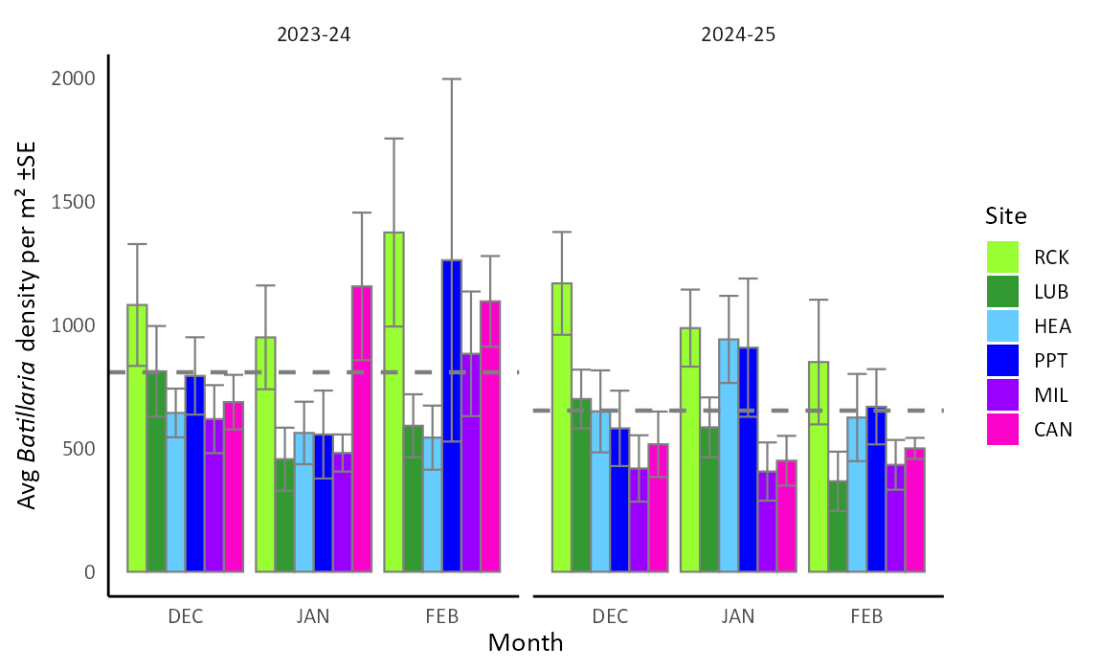
Figure 29: Average Batillaria australis densities within each site and month taken across the 2023-24 and 2024-25 seagrass monitoring seasons. Annual average for each seagrass sampling season (December – February) shown as dashed grey lines.

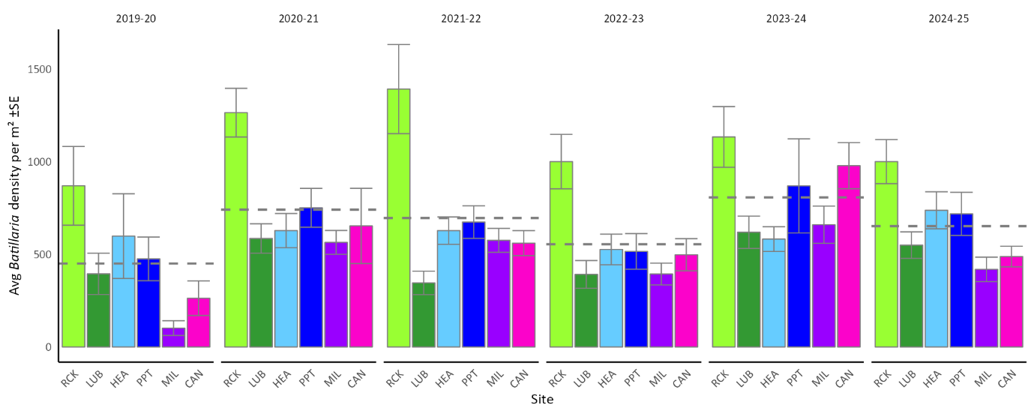
Figure 30: Average seagrass Batillaria australis within each site taken across 6 years of observation. Annual average for each seagrass sampling season (December – February) shown as dashed grey lines.

Appendices

Overall seagrass performance score
Supplementary table 1: Overall seagrass performance scores in the seasons 2023-24 and 2024-25 at each site.
 | RCK | LUB | HEA | PPT | MIL | CAN
2023/24 | 3.50 | 3.75 | 4.00 | 3.50 | 3.00 | 3.25
2024/25 | 3.75 | 3.25 | 4.00 | 3.75 | 3.25 | 3.25

Proportion of depths at each site
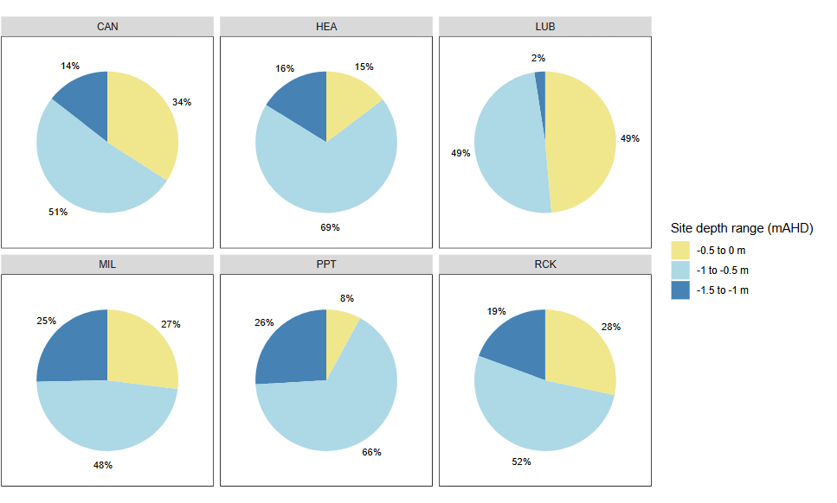
Supplementary figure 1: Depth range distribution at each site.

Seagrass species composition
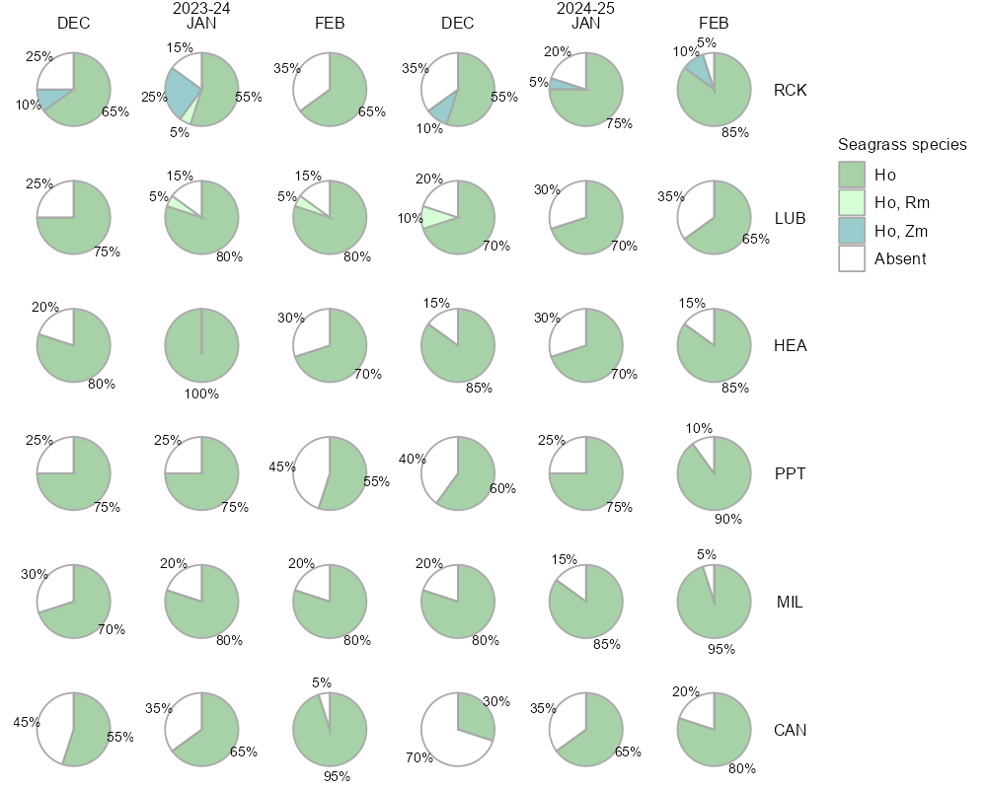
Supplementary figure 2: Average seagrass species composition (%) at each site across 2 years of observation (2023-24 and 2024-25). Species recorded: Halophila ovalis (Ho), Ruppia megacarpa (Rm) or Zostera muelleri subsp. mucronate (Zm). Where species composition was mixed the combination of species is assigned an individual category. Absent indicates no seagrass present.
This season’s surveys documented three of the six seagrass species that can occur in the Swan–Canning Estuary (Halophila ovalis, Ruppia megacarpa, and Zostera muelleri subsp. mucronata) within the monitored sites (Supplementary figure 2). Expectantly, the sites were dominated with Halophila ovalis, with the other species forming mixed meadows.

Nutrient levels and macroalgae cover in the Canning River
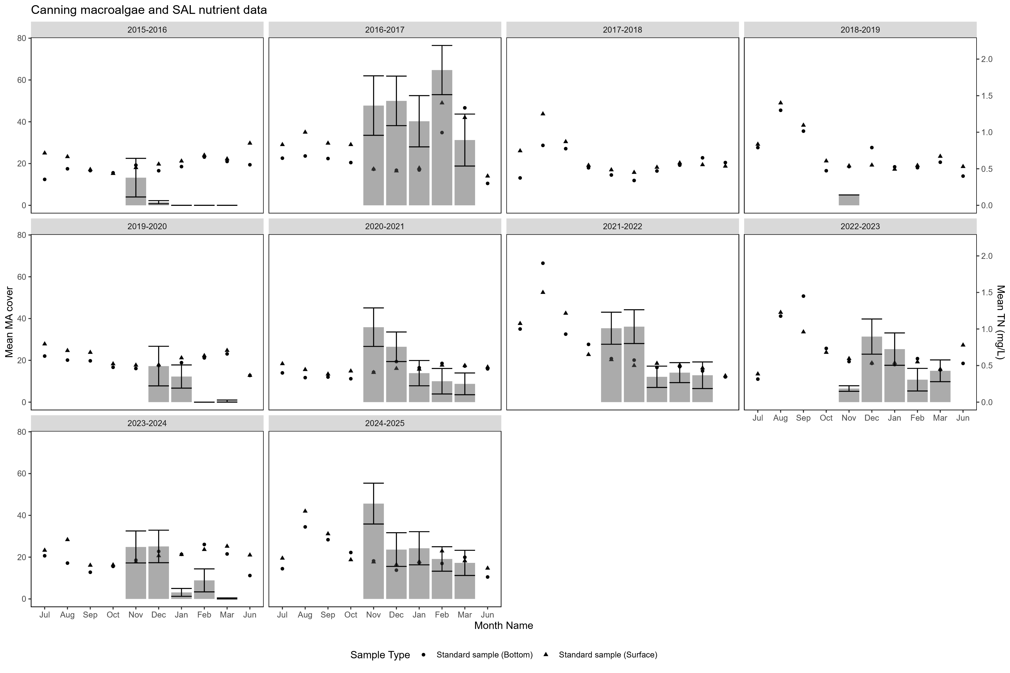
Supplementary figure 3: Average total nitrogen (mg/L) in water column at low depths (circle) and surface level (triangle), taken at the Rivers and Estuaries Science Water Quality Monitoring site Salter Point (SAL). Macroalgae is the average midpoint percent macroalgae cover observed at the seagrass monitoring site CAN, located adjacent to SAL.
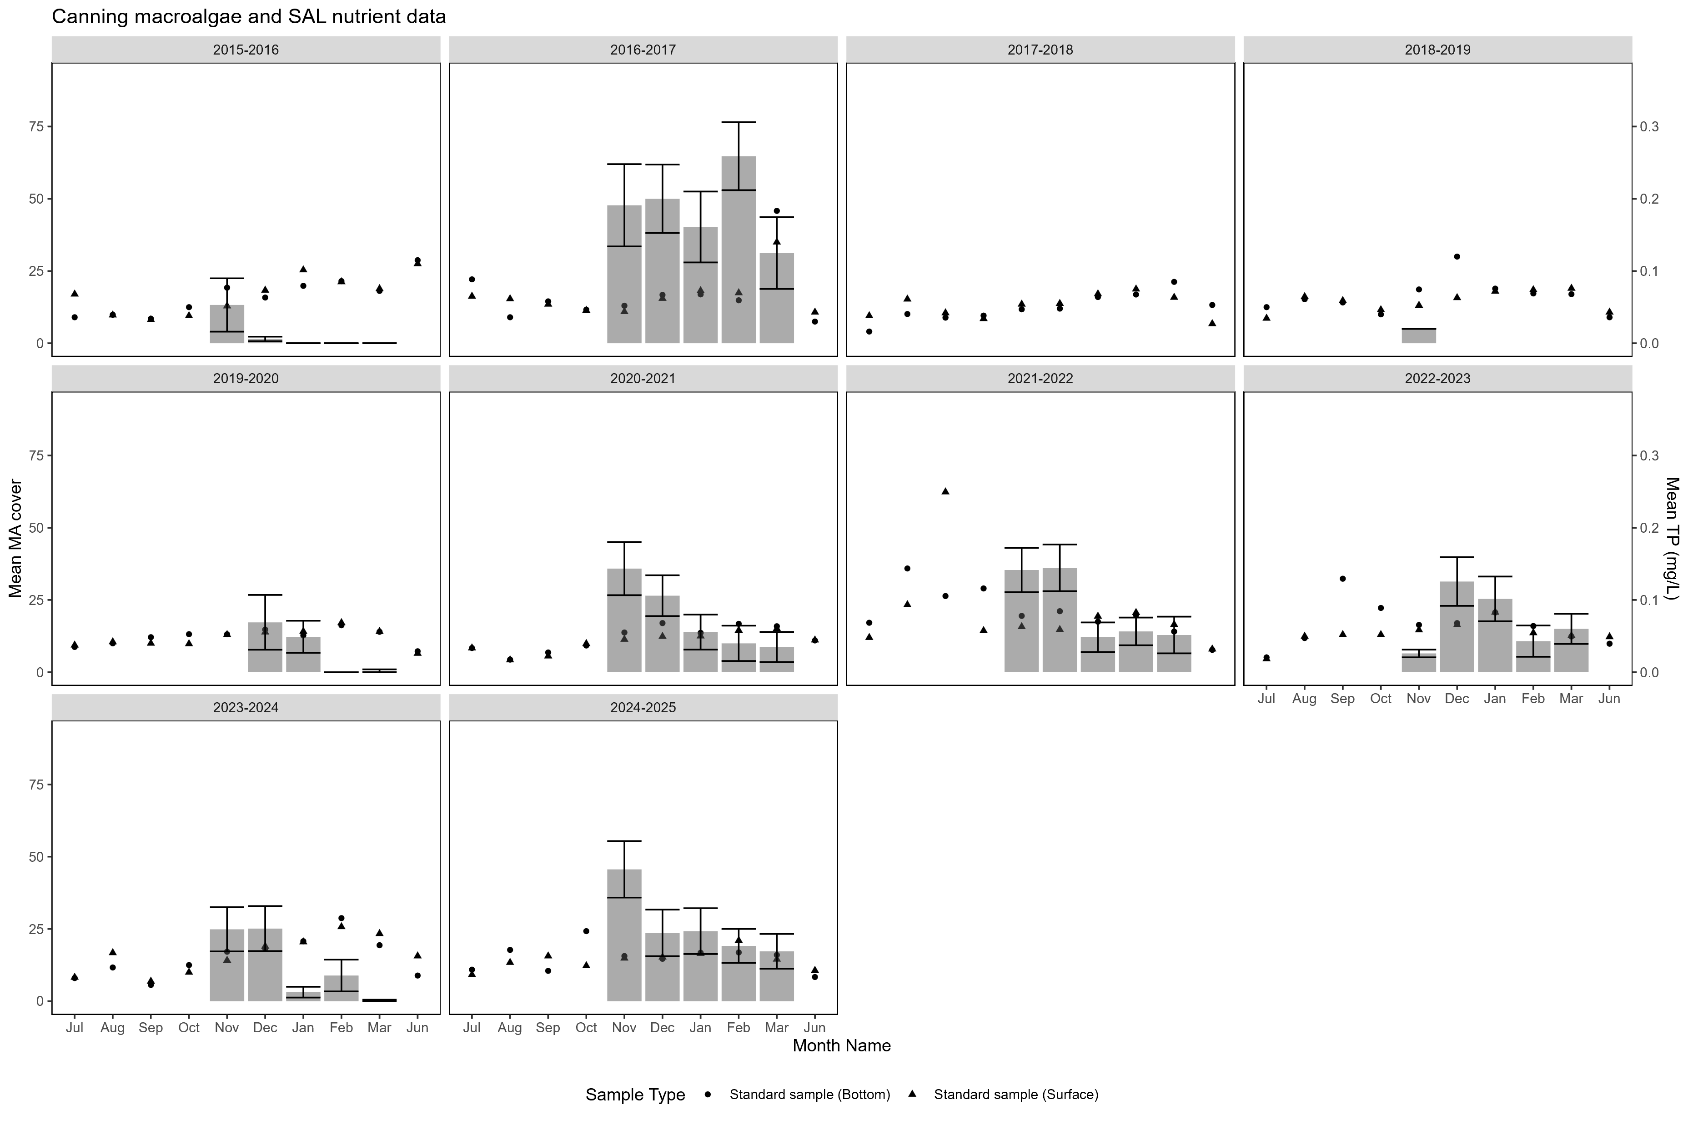
Supplementary figure 4: Average total phosphorus (mg/L) in water column at low depths (circle) and surface level (triangle), taken at the Rivers and Estuaries Science Water Quality Monitoring site Salter Point (SAL). Macroalgae is the average midpoint percent macroalgae cover observed at the seagrass monitoring site CAN, located adjacent to SAL.

January storm surge
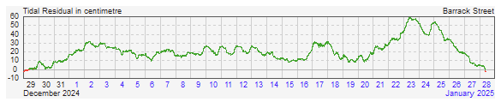
Supplementary figure 5: Tidal residual data (December 2024-January 2025) depicting the difference between the observed sea level and the predicted sea level. Additional storm surge occurred in January 2025 at Barrack Street Jetty (Department of Transport).

Statistical data

Statistical results - seagrass presence/absence
Supplementary table 2: Univariate three-way PERMANOVA on seagrass presence/absence. Outputs based on zero-adjusted Bray-Curtis similarity, performed with season, site and time as fixed factors. Significant values indicated in bold (p < 0.05).
Factor | df | SS | MS | Pseudo-F | Unique perms | p
Year | 1 | 2259.40 | 2259.40 | 13.49 | 4385 | <0.001
Month | 2 | 3018.80 | 1509.40 | 9.01 | 9536 | <0.001
Site | 5 | 7493.40 | 1498.70 | 8.95 | 9780 | <0.001
Year x Month | 2 | 900.31 | 450.15 | 2.69 | 9708 | 0.071
Year x Site | 5 | 1093.40 | 218.67 | 1.31 | 9866 | 0.256
Month x Site | 10 | 2901.50 | 218.15 | 1.73 | 9877 | 0.073
Year x Month x Site | 10 | 3094.10 | 309.41 | 1.85 | 9883 | 0.050

Supplementary table 3: PERMANOVA pairwise interactions on seagrass presence, showing only the significant interactions. Monte Carlo (MC) permutation test performed when an interaction uses <100 unique permutations.
Factor | Groups | t | Unique perms | p (MC)
Month (December) x Site (CAN) | Historical x 2024-25 | 3.18 | 9 | 0.002
Month (December) x Site (PPT) | Historical x 2024-25 | 2.56 | 8 | 0.012
Month (January) x Site (HEA) | Historical x 2024-25 | 3.50 | 7 | 0.001
Month (January) x Site (PPT) | Historical x 2024-25 | 2.02 | 10 | 0.047
Month (February) x Site (LUB) | Historical x 2024-25 | 2.44 | 11 | 0.016
Year (Historical) x Site (HEA) | December x January | 2.33 | 8 | 0.022
Year (Historical) x Site (HEA) | January x February | 2.73 | 8 | 0.007
Year (2024-25) x Site (CAN) | December x February | 3.58 | 6 | 0.001
Year (2024-25) x Site (CAN) | December x January | 2.31 | 7 | 0.023
Year (2024-25) x Site (MIL) | December x February | 2.15 | 4 | 0.040
Year (2024-25) x Site (PPT) | December x February | 2.28 | 6 | 0.030
Year (Historical) x Month (December) | CAN x HEA | 2.42 | 11 | 0.016
Year (Historical) x Month (December) | CAN x MIL | 2.87 | 10 | 0.005
Year (Historical) x Month (December) | CAN x PPT | 2.64 | 11 | 0.010
Year (Historical) x Month (December) | HEA x RCK | 2.93 | 11 | 0.005
Year (Historical) x Month (December) | LUB x RCK | 2.11 | 11 | 0.035
Year (Historical) x Month (December) | MIL x RCK | 3.38 | 12 | 0.001
Year (Historical) x Month (December) | PPT x RCK | 3.15 | 11 | 0.002
Year (Historical) x Month (January) | CAN x HEA | 4.02 | 9 | <0.001
Year (Historical) x Month (January) | CAN x MIL | 3.43 | 9 | 0.001
Year (Historical) x Month (January) | CAN x PPT | 3.15 | 10 | 0.003
Year (Historical) x Month (January) | HEA x LUB | 2.33 | 7 | 0.022
Year (Historical) x Month (January) | HEA x RCK | 3.67 | 10 | 0.001
Year (Historical) x Month (January) | MIL x RCK | 3.07 | 9 | 0.003
Year (Historical) x Month (January) | PPT x RCK | 2.79 | 9 | 0.005
Year (Historical) x Month (February) | CAN x MIL | 3.30 | 9 | 0.001
Year (Historical) x Month (February) | HEA x MIL | 2.73 | 8 | 0.007
Year (Historical) x Month (February) | LUB x RCK | 2.93 | 10 | 0.004
Year (Historical) x Month (February) | MIL x RCK | 4.56 | 11 | <0.001
Year (Historical) x Month (February) | PPT x RCK | 2.69 | 10 | 0.006
Year (2024-25) x Month (December) | CAN x HEA | 4.13 | 6 | <0.001
Year (2024-25) x Month (December) | CAN x LUB | 3.11 | 7 | 0.003
Year (2024-25) x Month (December) | CAN x MIL | 2.69 | 8 | 0.013
Year (2024-25) x Month (December) | CAN x RCK | 2.31 | 7 | 0.024
Year (2024-25) x Month (February) | LUB x MIL | 2.49 | 5 | 0.018
Year (2024-25) x Month (February) | MIL x RCK | 2.15 | 4 | 0.036

Statistical results - seagrass cover
Supplementary table 4: Univariate three-way PERMANOVA on seagrass cover. Outputs based on zero-adjusted Bray-Curtis similarity, performed with season, site and time as fixed factors. Significant values indicated in bold (p < 0.05).
Factor | df | SS | MS | Pseudo-F | Unique perms | p
Year | 1 | 12497.00 | 12497.00 | 12.11 | 9952 | <0.001
Month | 2 | 23507.00 | 11754.00 | 11.39 | 9957 | <0.001
Site | 5 | 56413.00 | 11283.00 | 10.93 | 9940 | <0.001
Year x Month | 2 | 4909.00 | 2454.50 | 2.38 | 9946 | 0.083
Year x Site | 5 | 9030.40 | 1806.10 | 1.75 | 9942 | 0.108
Month x Site | 10 | 12939.00 | 1293.90 | 1.25 | 9934 | 0.227
Year x Month x Site | 10 | 16385.00 | 1638.50 | 1.59 | 9920 | 0.086
Supplementary table 5: PERMANOVA pairwise interactions on seagrass cover, showing only the significant interactions.
Factor | Groups | t | Unique perms | p
Year | Historical x 2024-25 | 3.48 | 9939 | <0.001
Month | December x January | 3.78 | 9948 | <0.001
Month | December x February | 4.29 | 9933 | <0.001
Site | CAN x HEA | 5.32 | 9939 | <0.001
Site | CAN x LUB | 2.71 | 9937 | 0.005
Site | CAN x MIL | 4.88 | 9936 | <0.001
Site | CAN x PPT | 5.56 | 9939 | <0.001
Site | HEA x LUB | 2.66 | 9932 | 0.006
Site | HEA x MIL | 2.04 | 9939 | 0.028
Site | HEA x RCK | 3.29 | 9919 | <0.001
Site | LUB x MIL | 2.20 | 9944 | 0.021
Site | LUB x PPT | 3.06 | 9920 | 0.002
Site | MIL x PPT | 2.91 | 9940 | 0.003
Site | MIL x RCK | 3.13 | 9954 | 0.001
Site | RCK x PPT | 3.49 | 9926 | <0.001

Statistical results - reproduction
Supplementary table 6: Univariate three-way PERMANOVA on seagrass flower density. Outputs based on zero-adjusted Bray-Curtis similarity, performed with season, site and time as fixed factors. Significant values indicated in bold (p < 0.05).
Factor | df | SS | MS | Pseudo-F | Unique perms | p
Year | 1 | 1795.60 | 1795.60 | 0.98 | 9944 | 0.335
Month | 3 | 211520.00 | 70506.00 | 38.46 | 9958 | <0.001
Site | 5 | 19566.00 | 3913.30 | 2.13 | 9940 | 0.042
Year x Month | 3 | 12460.00 | 4153.40 | 2.27 | 9940 | 0.061
Year x Site | 5 | 13552.00 | 2710.50 | 1.48 | 9933 | 0.171
Month x Site | 15 | 34191.00 | 2279.40 | 1.24 | 9916 | 0.210
Year x Month x Site | 15 | 34955.00 | 2330.30 | 1.27 | 9897 | 0.189
Supplementary table 7: PERMANOVA pairwise interactions of seagrass flower density, showing only the significant interactions.
Factor | Groups | t | Unique perms | p
Month | December x January | 7.85 | 9939 | <0.001
Month | December x February | 2.14 | 9939 | 0.023
Month | December x March | 2.72 | 9938 | 0.006
Month | January x February | 5.68 | 9960 | <0.001
Month | January x March | 11.03 | 9942 | <0.001
Month | February x March | 4.95 | 9943 | <0.001
Site | HEA x PPT | 1.91 | 9939 | 0.047
Site | MIL x RCK | 2.07 | 9931 | 0.031
Site | PPT x RCK | 2.72 | 9935 | 0.004
Supplementary table 8: Univariate three-way PERMANOVA on seagrass fruit density. Outputs based on zero-adjusted Bray-Curtis similarity, performed with season, site and time as fixed factors. Significant values indicated in bold (p < 0.05).
Factor | df | SS | MS | Pseudo-F | Unique perms | p
Year | 1 | 11119.00 | 11119.00 | 8.09 | 9937 | 0.003
Month | 3 | 104235.00 | 34745.00 | 25.29 | 9954 | <0.001
Site | 5 | 52739.00 | 10548.00 | 7.68 | 9951 | <0.001
Year x Month | 3 | 9835.80 | 3278.60 | 2.39 | 9960 | 0.536
Year x Site | 5 | 12443.00 | 2488.50 | 1.81 | 9943 | 0.971
Month x Site | 15 | 34485.00 | 2299.00 | 1.67 | 9909 | 0.038
Year x Month x Site | 15 | 16476.00 | 1098.40 | 0.80 | 9910 | 0.690
Supplementary table 9: PERMANOVA pairwise interactions of seagrass fruit density, showing only the significant interactions.
Factor | Groups | t | Unique perms | p
Month x Site (CAN) | December x January | 3.13 | 9853 | 0.002
Month x Site (CAN) | December x February | 3.64 | 9919 | <0.001
Month x Site (CAN) | December x March | 3.31 | 9799 | 0.001
Month x Site (HEA) | December x February | 5.08 | 9903 | <0.001
Month x Site (HEA) | December x March | 4.44 | 9913 | <0.001
Month x Site (HEA) | January x February | 2.91 | 9936 | 0.003
Month x Site (HEA) | January x March | 2.42 | 9946 | 0.014
Month x Site (LUB) | December x January | 2.38 | 9833 | 0.018
Month x Site (LUB) | December x February | 2.67 | 2712 | 0.007
Month x Site (LUB) | December x March | 2.10 | 7860 | 0.035
Month x Site (MIL) | December x February | 3.23 | 9924 | 0.002
Month x Site (PPT) | December x January | 3.23 | 2720 | 0.023
Month x Site (PPT) | December x February | 3.03 | 8879 | 0.003
Month x Site (PPT) | December x March | 3.71 | 9344 | 0.001
Month x Site (RCK) | December x January | 3.91 | 9926 | <0.001
Month x Site (RCK) | December x February | 5.10 | 9940 | <0.001
Month x Site (RCK) | December x March | 5.58 | 9929 | <0.001
Month (Jan) x Site | HEA x RCK | 2.06 | 9928 | 0.037
Month (Jan) x Site | LUB x RCK | 1.94 | 9933 | 0.047
Month (Jan) x Site | MIL x RCK | 2.20 | 9931 | 0.023
Month (Jan) x Site | PPT x RCK | 2.41 | 9922 | 0.013
Month (Feb) x Site | CAN x HEA | 2.07 | 9941 | 0.034
Month (Feb) x Site | CAN x RCK | 2.26 | 9933 | 0.018
Month (Feb) x Site | HEA x LUB | 2.98 | 9929 | 0.003
Month (Feb) x Site | HEA x PPT | 2.18 | 9932 | 0.025
Month (Feb) x Site | LUB x RCK | 3.20 | 9939 | 0.001
Month (Feb) x Site | PPT x RCK | 2.37 | 9939 | 0.001
Month (Mar) x Site | CAN x RCK | 2.60 | 9923 | 0.007
Month (Mar) x Site | HEA x LUB | 2.58 | 9936 | 0.011
Month (Mar) x Site | HEA x MIL | 2.50 | 9931 | 0.011
Month (Mar) x Site | LUB x RCK | 3.54 | 9929 | <0.001
Month (Mar) x Site | MIL x RCK | 3.45 | 9932 | 0.001
Month (Mar) x Site | PPT x RCK | 2.37 | 9916 | 0.015

Statistical results – biomass
Supplementary table 10: Univariate three-way PERMANOVA on seagrass biomass. Outputs based on Euclidean distance resemblance matrix, performed with season, site and time as fixed factors. Significant values indicated in bold (p < 0.05).
Factor | df | SS | MS | Pseudo-F | Unique perms | perm
Year | 1 | 8.00 | 8.00 | 0.05 | 9925 | 0.91
Month | 3 | 1766.80 | 588.95 | 3.91 | 9941 | 0.007
Site | 5 | 15228.00 | 3045.70 | 20.24 | 9943 | 0.0001
Year x Month | 3 | 2532.40 | 844.15 | 5.61 | 9954 | 0.001
Year x Site | 5 | 1421.40 | 284.28 | 1.89 | 9939 | 0.085
Month x Site | 15 | 3592.60 | 239.50 | 1.59 | 9919 | 0.061
Year x Month x Site | 15 | 4339.90 | 289.33 | 1.92 | 9899 | 0.0155

Supplementary table 11: PERMANOVA pairwise interactions of seagrass biomass, showing only the significant interactions.
Factor | Groups | t | Unique perms | perm
Month (January) x Site (CAN) | 2023-24 x 2024-25 | 3.81 | 9407 | 0.002
Month (January) x Site (PPT) | 2023-24 x 2024-25 | 2.25 | 9403 | 0.034
Month (February) x Site (LUB) | 2023-24 x 2024-25 | 3.23 | 9424 | 0.000
Month (February) x Site (HEA) | 2023-24 x 2024-25 | 2.38 | 9395 | 0.025
Month (March) x Site (HEA) | 2023-24 x 2024-25 | 2.15 | 9393 | 0.040
Year (2023-24) x Site (HEA) | January x February | 2.53 | 9385 | 0.021
Year (2023-24) x Site (HEA) | January x March | 2.18 | 9408 | 0.035
Year (2023-24) x Site (LUB) | December x February | 2.47 | 9434 | 0.016
Year (2023-24) x Site (LUB) | January x February | 2.23 | 9425 | 0.036
Year (2023-24) x Site (MIL) | December x February | 2.46 | 9392 | 0.023
Year (2023-24) x Site (MIL) | January x February | 2.19 | 9390 | 0.000
Year (2023-24) x Site (MIL) | January x March | 2.25 | 9162 | 0.036
Year (2023-24) x Site (MIL) | February x March | 4.39 | 9106 | 0.001
Year (2023-24) x Site (PPT) | December x January | 3.17 | 9401 | 0.005
Year (2023-24) x Site (PPT) | December x March | 2.33 | 9420 | 0.024
Year (2023-24) x Site (PPT) | January x February | 2.55 | 9430 | 0.019
Year (2023-24) x Site (PPT) | January x March | 4.81 | 9397 | 0.000
Year (2024-25) x Site (CAN) | January x March | 2.99 | 9428 | 0.007
Year (2024-25) x Site (HEA) | December x January | 2.13 | 9380 | 0.049
Year (2024-25) x Site (RCK) | January x February | 2.23 | 9388 | 0.040
Year (2023-24) x Month (December) | HEA x MIL | 2.28 | 9398 | 0.033
Year (2023-24) x Month (December) | LUB x MIL | 2.82 | 9422 | 0.010
Year (2023-24) x Month (December) | MIL x PPT | 3.29 | 9461 | 0.002
Year (2023-24) x Month (December) | MIL x RCK | 2.60 | 9394 | 0.015
Year (2023-24) x Month (January) | CAN x MIL | 2.34 | 9423 | 0.030
Year (2023-24) x Month (January) | CAN x PPT | 4.26 | 9424 | 0.001
Year (2023-24) x Month (January) | HEA x MIL | 3.41 | 9374 | 0.004
Year (2023-24) x Month (January) | HEA x PPT | 2.72 | 9384 | 0.010
Year (2023-24) x Month (January) | LUB x MIL | 2.32 | 9410 | 0.028
Year (2023-24) x Month (January) | LUB x PPT | 2.04 | 9388 | 0.045
Year (2023-24) x Month (January) | MIL x PPT | 6.46 | 9422 | 0.000
Year (2023-24) x Month (January) | MIL x RCK | 3.17 | 9440 | 0.005
Year (2023-24) x Month (January) | PPT x RCK | 2.10 | 9409 | 0.044
Year (2023-24) x Month (February) | CAN x RCK | 3.04 | 9394 | 0.006
Year (2023-24) x Month (February) | HEA x RCK | 2.96 | 9432 | 0.006
Year (2023-24) x Month (February) | LUB x MIL | 2.08 | 9406 | 0.046
Year (2023-24) x Month (February) | LUB x PPT | 2.29 | 9391 | 0.024
Year (2023-24) x Month (February) | LUB x RCK | 3.50 | 9396 | 0.001
Year (2023-24) x Month (March) | CAN x RCK | 2.60 | 9437 | 0.012
Year (2023-24) x Month (March) | HEA x MIL | 2.50 | 9160 | 0.020
Year (2023-24) x Month (March) | HEA x RCK | 2.18 | 9445 | 0.034
Year (2023-24) x Month (March) | LUB x MIL | 3.70 | 9146 | 0.001
Year (2023-24) x Month (March) | LUB x RCK | 2.48 | 9423 | 0.018
Year (2023-24) x Month (March) | MIL x PPT | 2.13 | 9112 | 0.045
Year (2023-24) x Month (March) | MIL x RCK | 6.20 | 9202 | 0.000
Year (2023-24) x Month (March) | PPT x RCK | 2.50 | 9425 | 0.018
Year (2024-25) x Month (December) | CAN x PPT | 2.61 | 9456 | 0.016
Year (2024-25) x Month (December) | CAN x RCK | 2.28 | 9389 | 0.030
Year (2024-25) x Month (January) | CAN x HEA | 4.55 | 9396 | 0.001
Year (2024-25) x Month (January) | CAN x MIL | 2.61 | 9449 | 0.017
Year (2024-25) x Month (January) | CAN x PPT | 4.35 | 9407 | 0.001
Year (2024-25) x Month (January) | CAN x RCK | 4.29 | 9415 | 0.000
Year (2024-25) x Month (January) | HEA x MIL | 2.63 | 9400 | 0.015
Year (2024-25) x Month (January) | MIL x PPT | 2.41 | 9416 | 0.026
Year (2024-25) x Month (February) | CAN x HEA | 4.29 | 9409 | 0.000
Year (2024-25) x Month (February) | CAN x LUB | 3.83 | 9386 | 0.000
Year (2024-25) x Month (February) | CAN x PPT | 3.08 | 9381 | 0.006
Year (2024-25) x Month (February) | CAN x RCK | 5.79 | 9428 | 0.000
Year (2024-25) x Month (February) | HEA x MIL | 2.91 | 9403 | 0.009
Year (2024-25) x Month (February) | HEA x RCK | 2.33 | 9386 | 0.031
Year (2024-25) x Month (February) | LUB x MIL | 3.01 | 9393 | 0.007
Year (2024-25) x Month (February) | MIL x PPT | 2.43 | 9175 | 0.024
Year (2024-25) x Month (February) | MIL x RCK | 4.33 | 9413 | 0.001
Year (2024-25) x Month (March) | CAN x HEA | 2.23 | 9424 | 0.040
Year (2024-25) x Month (March) | CAN x MIL | 2.23 | 9379 | 0.038
Year (2024-25) x Month (March) | CAN x RCK | 2.98 | 9391 | 0.011
Year (2024-25) x Month (March) | HEA x MIL | 3.90 | 9384 | 0.002
Year (2024-25) x Month (March) | LUB x RCK | 2.27 | 9438 | 0.362
Year (2024-25) x Month (March) | MIL x PPT | 3.14 | 9441 | 0.006
Year (2024-25) x Month (March) | MIL x RCK | 5.33 | 9391 | 0.002

Glossary
CAN  DBCA  DWER  the Estuary  HEA  H_{comp}  I_{c}  I^{k}  Isotope  LUB  MIL  MJ  PAR  PPT  ppt  RCK  SE  Quadrat | The site Canning  Department of Biodiversity, Conservation and Attractions  Department of Water and Environmental Regulation  The Swan-Canning Estuary  The site Heathcote  Hours of light above the compensation point  Light levels at the compensation point  Light levels above the saturation point  Elements which have the same number of protons and differing numbers of neutrons, therefore have different atomic weights, but almost identical chemical properties.  The site Lucky Bay  The site Milyu  Megajoule/s  Photosynthetically Active Radiation  The site Pelican Point  Parts per thousand  The site Rocky Bay  Standard error  A square plot used to quantify seagrass measurements in a standardised manner

Swan River Trust (2024). River Protection Strategy for Derbal Yirragan Djalgarro (Swan Canning river system). Department of Biodiversity, Conservation and Attractions. Perth, Western Australia.
Arani Chandrapavan (2025). Western Australia's marine heatwave updates - Feb – June. Department of Primary Industries and Regional Development, Western Australia.
Haigh, I. D., Eliot, M., & Pattiaratchi C. (2011), Global influences of the 18.61 year nodal cycle and 8.85 year cycle of lunar perigee on high tidal levels. Journal of Geophysical Research, 116(C06), https://doi.org/10.1029/2010JC006645.
Charlie Phelps, Peter Howie, Graham Loewenthal, Jeff Cosgrove (2025). Information Sheet 114/2025 - Seagrass map for the Swan Canning Estuary. Department of Biodiversity, Conservation and Attractions. https://doi.org/10.71726/86k55il6
Strydom, S., McMahon, K., Kendrick, G.A., Statton, J., & Lavery, P.S. (2017). Seagrass Halophila ovalis is affected by light quality across different life history stages. Marine Ecology Progress Series, (572), 103-116, https://doi.org/10.3354/meps12105.
Nguyen, V. X., Detcharoen, M., Tuntiprapas, P., Soe-Htun, U., Sidik, J. B., Harah, M. Z., Prathep, A., & Papenbrock, J. (2014). Genetic species identification and population structure of Halophila (Hydrocharitaceae) from the Western Pacific to the Eastern Indian Ocean. BMC Evolutionary Biology, 14. Article 92. https://doi.org/10.1186/1471-2148-14-92.
Azcárate-García, T., Beca-Carretero, P., Villamayor, B., Stengel, D.B. & Winters, G. (2020). Responses of the seagrass Halophila stipulacea to depth and spatial gradients in its native region (Red Sea): morphology, in situ growth and biomass production. Aquatic Botany. 165, https://doi.org/10.1016/j.aquabot.2020.103252.
Australian Institute of Marine Science. (2025, August 12). Worst bleaching event on record for WA coral reefs following long lasting and widespread marine heatwave [Press release]. The Australian Institute of Marine Science | AIMS
Webster, C. L., Kilminster, K. L., Sánchez Alarcón, M., Bennett, K., Strydom, S., McNamara, S., Lavery, P., & McMahon, K. M. (2021). Population‐specific resilience of Halophila ovalis seagrass habitat to unseasonal rainfall, an extreme climate event in estuaries. Journal of Ecology, 109(9), 3260-3279. https://doi.org/10.1111/1365-2745.13648
Longstaff, B. J., Loneragan, N. R., O'Donohue, M. J., & Dennison, W. C. (1999). Effects of light deprivation on the survival and recovery of the seagrass Halophila ovalis (R. Br.) Hook. Journal of Experimental Marine Biology and Ecology, 234(1), 1–27, https://doi.org/10.1016/S0022-0981(98)00137-3
Collier, C. J., Adams, M. P., Langlois, L., Waycott, M., O'Brien, K. R., Maxwell, P. S., McKenzie, L. (2016). Thresholds for morphological response to light reduction for four tropical seagrass species. Ecological Indicators. 67. 358-366. https://doi.org/10.1016/j.ecolind.2016.02.050
Dailer, M. L., Smith, J. E., Smith, C. M. (2012). Responses of bloom forming and non-bloom forming macroalgae to nutrient enrichment in Hawai’i, USA. Harmful Algae. 17. Pp. 111-125. DOI: 10.1016/j.hal.2012.03.008
Thomsen, M.S., Wernberg, T., Tuya, F., & Silliman, B. R. (2010). Ecological performance and possible origin of a ubiquitous but under-studied gastropod. Estuarine, Coastal and Shelf Science, 87(4), 501-509. https://doi.org/10.1016/j.ecss.2010.02.014
Phelps, C. M, Howie P. A., Loewenthal, G., Cosgrove, J. (2025). Information Sheet 114/2025 - Seagrass map for the Swan Canning Estuary [Data set]. Department of Biodiversity, Conservation and Attractions. https://doi.org/10.71726/86k55il6
Forbes, V.R. and Kilminster, K. (2016). Monitoring seagrass extent and distribution in the Swan-Canning estuary. Water Science Technical Series, Report no. 70, Western Australia Department of Water, Perth.
Phelps, C. M., Howie, P. A., & Cosgrove, J. (2025). Seagrass indicators of estuary health 2021-22, Annual report, Department of Biodiversity, Conservation and Attractions, Perth.

