Trapdoor Tally
Trapdoor spiders belong to the Mygalomorph group, which includes the tarantulas and funnel web spiders. Many are short-range endemic species, that occur in small, restricted areas of suitable habitat. We know they need undisturbed native vegetation with shady areas, a mix of low shrubs, woody debris, leaf litter and bare earth. They don’t like weeds and are indicators of healthy bushland with an intact ground, invertebrate community.
The Trapdoor Tally will focus on trapdoor species with open burrows (no lid), that can be more easily seen. Examples include the Wishbone Spider (Aname mainae), and another, relatively common trapdoor on the Swan Coastal Plain, the Lidless Banksia Trapdoor Spider (Proshermacha tepperi).
These trapdoor burrows are circular, tend to be vertical and located at the base of a tree, shrub or tuft of grass. Please take a ruler with you and measure the diameter of the burrow (without disturbing the entrance). If small as well as large burrows are present, there is recruitment of young spiders into the population.
If you see a different type of burrow, with a lid, it could belong to one of fifteen or so, other trapdoor spider species, that occur on the Swan Coastal Plain. Please take a photo and record the location.
If you think you might have trapdoors in your local reserve and would like to do a count for us, please get in touch with Dr Geoff Barrett, Department of Biodiversity, Conservation and Attractions (geoff.barrett@dbca.wa.gov.au).
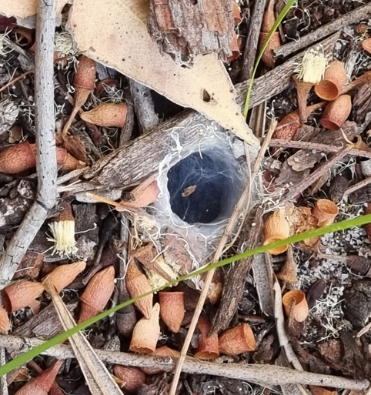  Trapdoor Spider burrow (possibly Aname tepperi) | 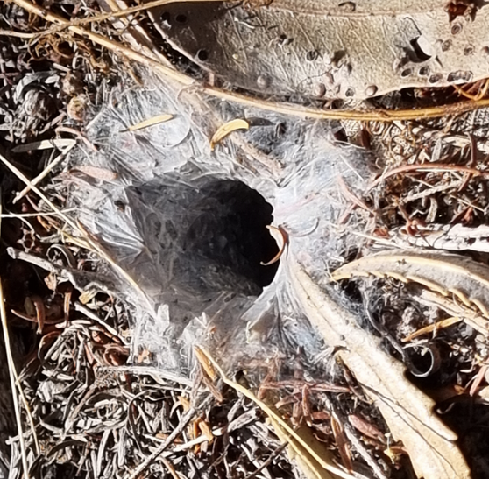  Trapdoor Spider burrow (possibly Aname tepperi)
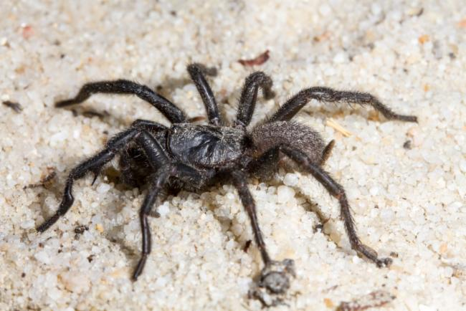  Black Wish-bone Spider (Aname mainae)  (image from the Atlas of Living Australia) | 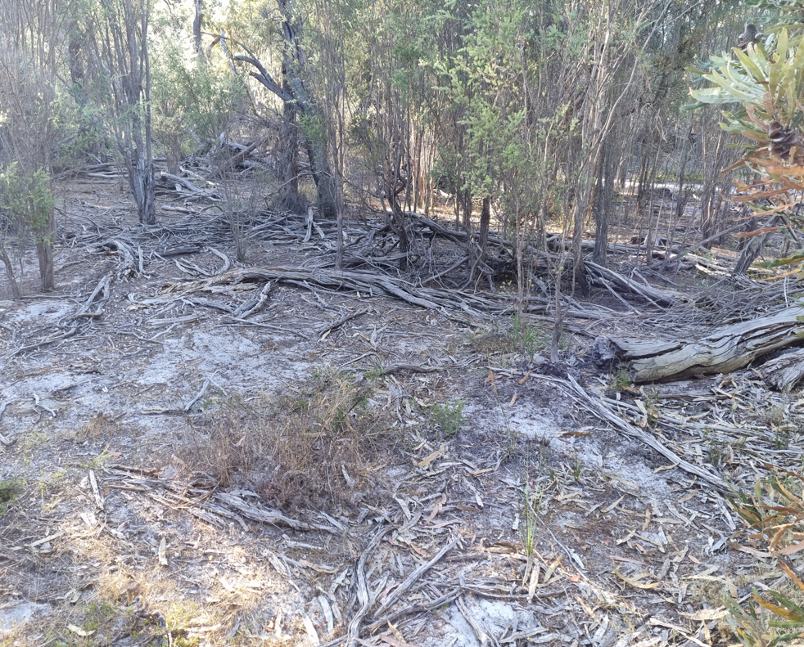  The type of habitat trapdoors like

Trapdoor Tally Survey Method
- Choose a patch of bushland that is in good condition, where you think trapdoor spiders occur.
- Record the location of the search area, date, and time of survey.
- Walk slowly through the bush for 20 minutes, looking at the ground in front of you (within 2-3m),
- Mark the start of the survey with your GPS unit and stay within 200 metres of this point.
- Try not to cover the same ground twice.
- If you find a trapdoor burrow, record it and measure the diameter of the entrance.
- Only count burrows that you are sure belong to a spider, having clearly visible web around the entrance.
- Take a photo if you are unsure.
- Trapdoor burrows will tend to cluster, so if you find one, look nearby for others.
- Target areas with patches of bare sand and leaf litter, low shrubs, shade, logs, and woody debris.
- Careful not to count the same burrow twice.
- If you don’t find any burrows, please record this, and send your data sheet in (zero counts are important).

Name of site: |  | Date: | Time Start:  (20-minute survey)
Name and contact number of main observer(s):  Number of people searching: |  | Main forest type  Quenda Diggings present (Y/N) | (e.g. Banksia Woodland, jarrah forest)
Site description:  Has there been a fire recently, of so,  how long ago? |  | Latitude:  Longitude:
Diameter of burrow (mm)  or ‘Not measured’ | Does the burrow have a lid (Yes or No). If yes, please take a photo. | Does the burrow look active (with fresh web) Yes or No | Comment
 | Total number of Active | Burrows (with web):
Comments:
Trapdoor Tally Habitat Survey
This is a separate survey that will be sent to people who have located trapdoor burrows and are happy to provide some additional habitat information.
- Record the nearest tree species to the burrow.
- Take a photo of a one-meter square area (roughly), with the trapdoor burrow in the centre.
- Include in the photo, a metric ruler on the ground, close to the burrow, so we can estimate distances.
- Standing in the same position, take a photo looking at the vegetation straight ahead (camera pointing in the same direction as the burrow).
- Remaining in the same position, take a third photo, looking vertically upwards towards the tree canopy (or sky if there is no tree canopy above).

