Wirambi Landcare Trapdoor Tally – Summary Update
Dr Geoff Barrett (Regional Ecologist, Swan Region)
January 2026

Summary
Between summer 2023 and 2025, a total of 224 surveys were completed by 56 community volunteers, across 170 sites in the Swan Region (Figure 1). Of these 170 sites, 20-minute transect searches were carried out in 94 sites, the remainder being sites where opportunistic trapdoor sightings were made (Table 1).
Of the 94 sites where 20-minute searches were carried out, 26 sites (28%) had trapdoors present (Table 2). So, just over a quarter of all sites surveyed across the Swan Region, had trapdoors present. Note that surveys generally targeted sites with good condition habitat, thought to be suitable for trapdoors.
The highest density of trapdoor burrows occurred at Lowlands Nature Reserve, with an average of 11.7 burrows per hectare (Table 3).
Of 189 burrows measured across all sites, 40 (21%) were small (<14mm) suggesting that recruitment of young spiders is occurring. The highest level of recruitment occurred in the Wandoo National Park sites (50%).

Objectives of the Trapdoor Tally
- To establish a set of monitoring sites where trapdoor burrows are counted annually using a robust, repeatable method.
- To capture data about Trapdoor Spiders, that can be used as a reference for population trends, future planning decisions and conservation projects.
- To provide data on the distribution and abundance of Trapdoor Spiders in the Greater Perth Region.
- To raise awareness in the community about Trapdoor Spiders, some of which are endangered.
- To engage the community in citizen science to assist with Trapdoor Spider conservation.

Background
The Trapdoor Tally coordinated by Wirambi Landcare, has been running since December 2023 with 20-minute transect walks and incidental sightings being recorded across the Swan Region. The intention is that the Tally be run as an annual survey, allowing reporting rates of burrowing activity to identify sites where trapdoors occur, and serve as an indication of changes in abundance from year to year.
Trapdoor spiders belong to the Mygalomorph group, which includes the tarantulas and funnel web spiders. Many are short-range endemic species, that occur in small, restricted areas of undisturbed native vegetation with shady areas, a mix of low shrubs, woody debris, leaf litter and bare earth. They don’t like dense weed cover and are indicators of healthy bushland with an intact ground-dwelling, invertebrate community.
At this stage, the 20-minute transect searches were only used to detect lidless trapdoors. There are two relatively common species in the Perth Region; the Wishbone Spider (Aname mainae), that has round, vertical burrows, without much web, that are easily seen in open, sandy areas. Wishbone spiders are less active over summer, when they appear to cover their burrows with leaves, and when the males are vulnerable to wildfire, as they disperse to find females and new territories.
The other relatively common trapdoor on the in the Perth Region, is the Lidless Banksia Trapdoor Spider (Proshermacha tepperi). These have large, easy to see, web funnels, often raised above ground, within low, dense vegetation. The females put their webs out and make them look nice in the summer months (Doilies), to attract males, and disperse in the winter/autumn. They are larger than the Aname, able to eat small lizards (baby skinks).
Future surveys will be designed to monitor trapdoor species that have lids over the entrance to their burrows, including Idiosoma sigillatum, which is listed as Threatened.

Survey Method
A 20-minute area search method was used, with the observer walking slowly, scanning the ground and recording any burrows seen (within 2.5m either side of the observer). See survey sheet in Appendix for further details.
The diameter of a sub-sample of burrows was measured at the widest point, using a metric ruler (without disturbing the entrance).
Also, for a sub-set of surveys, a GPS track log was used to measure the distance walked during the 20-minute survey. Assuming a five metre wide survey strip, the area surveyed can be calculated by multiplying the distance walked by the width of the transect.
Most surveys were completed in the spring (62%) and summer (23%) months, although, surveys can be done all year round.

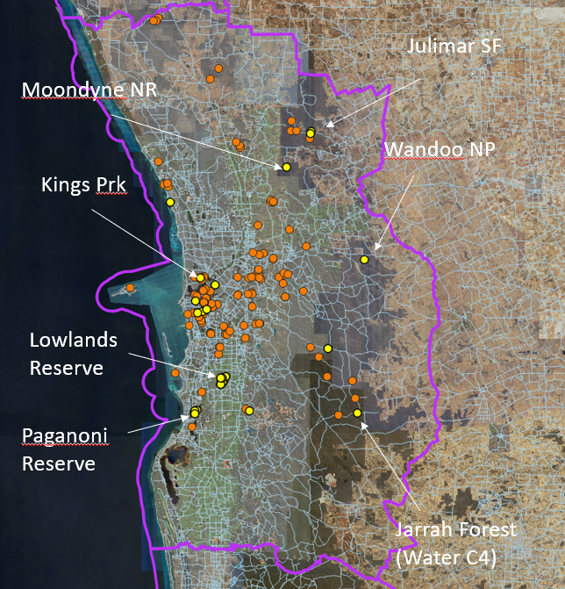
Figure 1: Location of 170 Trapdoor Tally survey sites (Yellow dots = Trapdoors present)

Table 1: Summary of Trapdoor Tally data across all years (2023 to 2025)
Number of sites where 20-minute transect searches were carried out | 94
Number of 20-minute transect searches | 150
Avg number of 20-minute surveys per site | 1.6
Avg number of Trapdoor burrows per 20-survey (across all sites) | 1.2
Number of 20-minute surveys with trapdoors present | 48 (32%)
Total number of active Trapdoor burrows recorded (during 20-minute search) | 146
Number of sites with Trapdoor burrows present during 20-minute survey | 26 (28%)
Avg number of Trapdoor burrows per survey, in sites where Trapdoors were recorded as present | 4.0
Average diameter of the burrows (n=189) | 17 (mm)
% burrows >21mm diameter (n=24 burrows) | 13%
% burrows 16-20mm diameter (n=91 burrows) | 48%
% burrows<14mm diameter (n=40 burrows) | 21%
Average distance from observer to burrow, when first sighted (n=66) | 1.2(m)
Total number of volunteers involved  (volunteers from Murdoch Uni and Mandurah Tafe, Friends of Booragoon and Blue Gum Lakes and the Rehabilitating Roe 8 group) | 56
Total number of surveys (including opportunistic sightings) | 224
Total number of sites surveyed (including opportunistic sightings) | 170

Table 2: Sites where trapdoors were present during 20-minute transect searches. Recruitment of young trapdoor spiders was estimated by looking at the proportion of small (<14mm) burrows, in three sites, where at least 20 burrows were measured.
Reserve Name | Lat | Long | % Recruitment occurring (n=# burrows measured)
Lowlands Nature Reserve | -32.338152 | 115.912448 | 16% (n=134)
Kings Park | -31.963153 | 115.822269
Flint Block (Jarrah Forest, Nth Bannister) | -32.453495 | 116.481414
Paganoni Bushland | -32.439971 | 115.794867 | 28% (n=25)
Myara Forest Block (Nth Dandalup NR) | -32.441425 | 116.025169
Olding Park, Melville (?) | -32.045003 | 115.802709
Whistlepipe Gully | -32.985355 | 116.0354978
Murdoch Tafe, Murdoch | -32.076 | 115.848
Moondyne Nature Reserve | 31.56703 | 116.19004
Roe 8 (in remnant bushland near Bibra Lake) | -32.088247 | 115.8094229
Wandoo NP (Chidlow - York Rd) | -31.899963 | 116.514792 | 50% (n=22)
Julimar State Forest | -31.438116 | 116.293416

Trapdoor recruitment
An indication of whether trapdoor populations are self-sustaining and replacing themselves, can be gauged by recording the diameter of the burrows. If there are small (<15mm diameter), as well as, large burrows (>20mm diameter), the population contains both mature adults and juveniles. By tracking the proportion of small holes over time, changes in the recruitment rate of juveniles can be identified.
The average size of the burrows recorded was 17mm (n=189 burrows measured). The presence of small burrows (<14mm) indicates that recruitment of young spiders is occurring. Of the 189 burrows measured across all sites, 40 had a diameter smaller than 14mm (21%, Figure 2).
Recruitment was assessed in three sites where at least 20 burrows were measured (Table 2). Half of the burrows were smaller than 14mm diameter in the Wandoo NP site (50% recruitment, n=22 burrows measured), 28% were smaller than 14mm in Paganoni Bushland (n=25 burrows measured), and 16% in Lowlands Nature Reserve (n=134).

Figure 2: Frequency histogram of burrow diameters across all sites (n=189 burrows measured)

Population Density
The average distance from the observer to the burrow, when initially sighted, was recorded at a subset of sites. This average distance was 1.15m (max=2m, min=0.5m, n=66 sightings). Based on this figure, it is assumed that all visible burrows, were recorded within 2.5m, either side of the observer. This measure (average transect width = 5m), combined with the average length of the transect, provides an estimate of the area surveyed. A GPS tracker was used to calculate the average distance walked during a 20-minute survey.
To calculate density, the average number of burrows per survey, was divided by the average area (Ha) of the transect surveyed, then multiplied 10,000 to convert the measure to burrows per hectare. D
The density estimates in this report, were calculated for a selection of sites at six locations (Table 3), where at least two burrows were recorded (a strip transect width of 5m was assumed, and estimates of the transect length were based on the average across each location).

Table 3: Density of Trapdoor burrows, at six locations (see Figure 1), where at least two transect surveys were completed and at least two burrows were recorded across all of those surveys (a strip transect width of 5m was assumed, and estimates of the transect length were based on the average across each location).

Location | # sites surveyed | #Surveys | Avg length of transect (m) | Avg area of transect (Ha) | Avg # burrows per survey | Avg # burrows per Hectare
Lowlands  Nature Reserve | 7 | 29 | 700 (n=17) | 0.35 | 4.1 | 11.7
Paganoni Bushland | 5 | 8 | 980 (n=2) | 0.49 | 2.75 | 5.6
Myara Forest Block (Nth Dandalup NR) | 2 | 3 | 575 (n=3) | 0.29 | 1.3 | 4.5
Roe 8 (Remnant Veg near Bibra Lake) | 4 | 4 | 728 (overall average) | 0.36 | 1.25 | 3.5
Murdoch Tafe, Murdoch | 3 | 4 | 728 (overall average) | 0.36 | 0.5 | 1.4
Flint Block (Jarrah Forest, Nth Bannister) | 6 | 10 | 836 (n=4) | 0.41 | 0.2 | 0.5

Appendix: Trapdoor Tally – Data Sheet
Trapdoor spiders belong to the Mygalomorph group, which includes the tarantulas and funnel web spiders. Many are short-range endemic species, that occur in small, restricted areas of suitable habitat. We know they need undisturbed native vegetation with shady areas, a mix of low shrubs, woody debris, leaf litter and bare earth. They don’t like weeds and are indicators of healthy bushland with an intact ground, invertebrate community.
The Trapdoor Tally will focus on trapdoor species with open burrows (no lid), that can be more easily seen. Examples include the Wishbone Spider (Aname mainae), and another, relatively common trapdoor on the Swan Coastal Plain, the Lidless Banksia Trapdoor Spider (Proshermacha tepperi).
These trapdoor burrows are circular, tend to be vertical and located at the base of a tree, shrub or tuft of grass. Please take a ruler with you and measure the diameter of the burrow (without disturbing the entrance). If small as well as large burrows are present, there is recruitment of young spiders into the population.
If you see a different type of burrow, with a lid, it could belong to one of fifteen or so, other trapdoor spider species, that occur on the Swan Coastal Plain. Please take a photo and record the location.
If you think you might have trapdoors in your local reserve and would like to do a count for us, please get in touch with Dr Geoff Barrett, Department of Biodiversity, Conservation and Attractions (geoff.barrett@dbca.wa.gov.au).
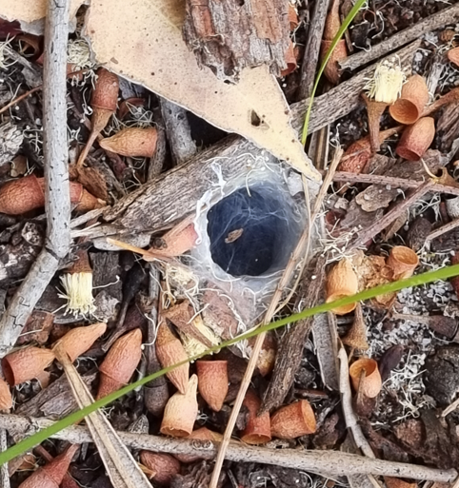  Trapdoor Spider burrow (possibly Aname tepperi) | 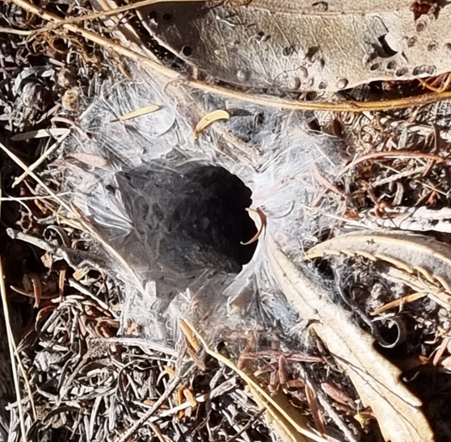  Trapdoor burrow (possibly Aname tepperi)
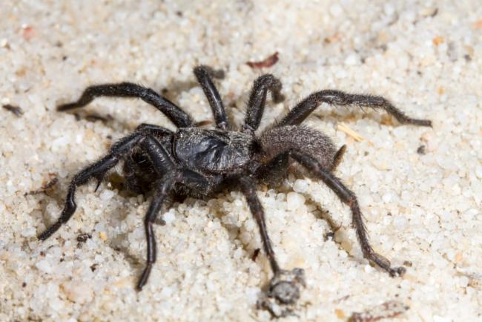  Black Wish-bone Spider (Aname mainae)  (image from the Atlas of Living Australia) | 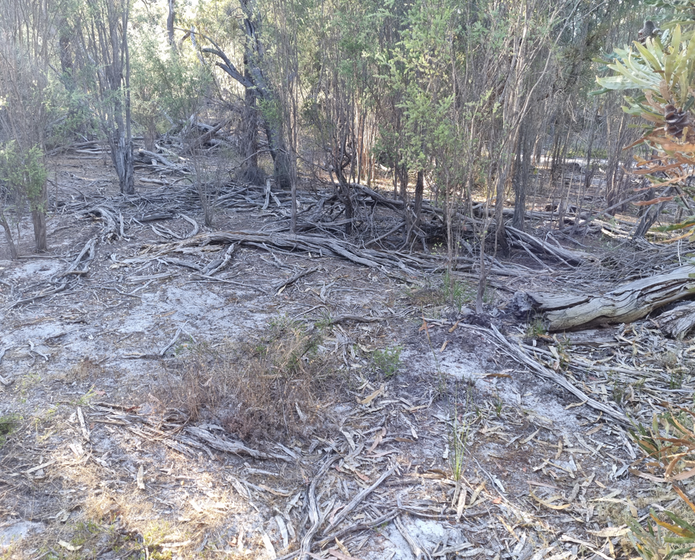  The type of habitat trapdoors like
Trapdoor Tally Survey Method
- Choose a patch of bushland that is in good condition, where you think trapdoor spiders occur.
- Record the location of the search area, date, and time of survey.
- Walk slowly through the bush for 20 minutes, looking at the ground in front of you (within 2-3m),
- Mark the start of the survey with your GPS unit and stay within 200 metres of this point.
- Try not to cover the same ground twice.
- If you find a trapdoor burrow, record it and measure the diameter of the entrance.
- Only count burrows that you are sure belong to a spider, having clearly visible web around the entrance.
- Take a photo if you are unsure.
- Trapdoor burrows will tend to cluster, so if you find one, look nearby for others.
- Target areas with patches of bare sand and leaf litter, low shrubs, shade, logs, and woody debris.
- Careful not to count the same burrow twice.
- If you don’t find any burrows, please record this, and send your data sheet in (zero counts are important).
Name of site: |  | Date: | Time Start:  (20-minute survey)
Name and contact number of main observer(s):  Number of people searching: |  | Main forest type  Quenda Diggings present (Y/N) | (e.g. Banksia Woodland, jarrah forest)
Site description:  Has there been a fire recently, of so,  how long ago? |  | Latitude:  Longitude:
Diameter of burrow (mm)  or ‘Not measured’ | Does the burrow have a lid (Yes or No). If yes, please take a photo. | Does the burrow look active (with fresh web) Yes or No | Comment
 | Total number of Active | Burrows (with web):

